Name: __________________________________________________________
Art HERStory
In class, we have looked at many ways that artists have portrayed women in their artworks. For the final unit exam, I want to test an accumulation of your knowledge based on what we have learned so far. Consider how we have discussed: the roles of women in the 1600s to now, specific artists or groups of artists who have spoken out about how women have been portrayed in art and in the general art world, along with the question “Why are there no great women artists?” during your response. Everything that we have discussed from the beginning of the unit to now can be used as reference to your answers.

The Task:
-Given the information, compare AND contrast the way that the artist has portrayed the subject.
-We are not focusing so much on what the subject is doing, but HOW the artist is portraying it.
-How has the subject been portrayed? Does the medium affect this?
1. How have the different artists represented the subject matter in similar ways?
2. How have the different artists represented the subject matter in different ways?
3. Given the opportunity, how would YOU have represented the subject matter?
4. What do you think the artists are saying about the subject matter given the way that they have represented the subject in the artwork?

20 points per paragraph with an additional 20 points for grammar, spelling, and cohesiveness.

Mary Cassatt “Children Playing on the Beach” 1884. Oil on canvas.
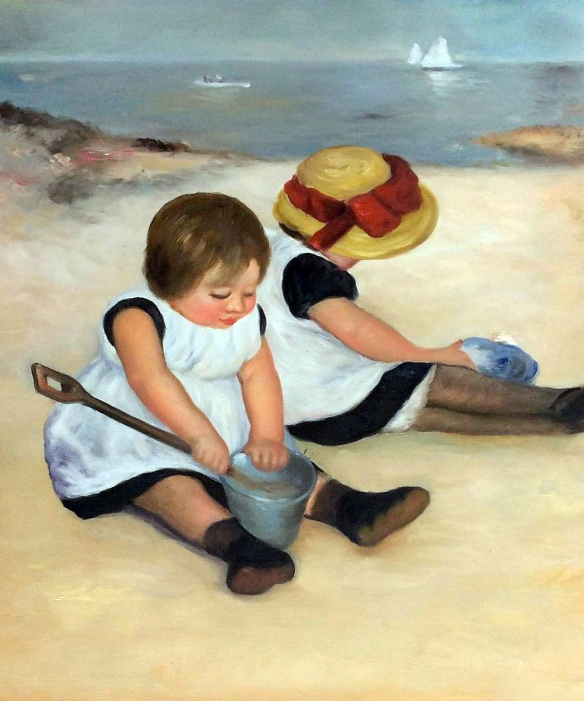

Pierre-Auguste Renior “Two Sisters (On the Terrace)” 1881. Oil on canvas.
