Name: _________________________________________ Class: ___________________ Date: ________
Art II Final Exam Review
What is balance? _______________________________________________________________________
_____________________________________________________________________________________
_____________________________________________________________________________________
Draw an example of each type of balance in the space provided.
Symmetrical | Asymmetrical | Radial

What is a pattern? _____________________________________________________________________
_____________________________________________________________________________________
_____________________________________________________________________________________
Create a pattern using a combination of letters and numbers

What is variety? _____________________________________________________________________
_____________________________________________________________________________________
_____________________________________________________________________________________
Draw a variety of symbols or objects below (use at least 5)

What is gradation? _____________________________________________________________________
_____________________________________________________________________________________
_____________________________________________________________________________________
Gradually show a decrease in the size of a triangle

What is proportion? ____________________________________________________________________
_____________________________________________________________________________________
_____________________________________________________________________________________
Show an example of proportion below.

What is emphasis? _____________________________________________________________________
_____________________________________________________________________________________
_____________________________________________________________________________________
Write your name in the box below and emphasize one of the letters.

What is movement? ____________________________________________________________________
_____________________________________________________________________________________
_____________________________________________________________________________________
Draw a bumble bee and use line to show the path that he traveled.
What is rhythm? ______________________________________________________________________
_____________________________________________________________________________________
_____________________________________________________________________________________
What are the differences between harmony and unity?
Harmony | Unity

What is a horizon line? __________________________________________________________________
_____________________________________________________________________________________
_____________________________________________________________________________________
What is a vanishing point? _______________________________________________________________
_____________________________________________________________________________________
_____________________________________________________________________________________
Demonstrate two buildings below: one taller than the horizon line, & one shorter than the horizon line.

Name an example of physical space. _______________________________________________________

Complete the venn-diagram below:
Portraits Self-Portraits
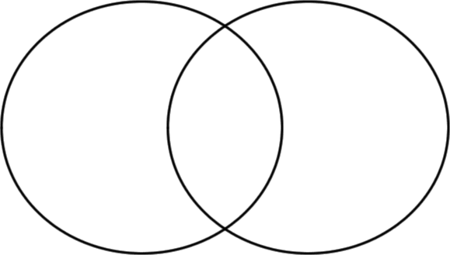

Show a color transformation: Begin with a tint, turn it into a hue, and end with a shade.
Tint |  | Hue |  | Shade

What is a metamorphosis? _______________________________________________________________
_____________________________________________________________________________________
_____________________________________________________________________________________
What is symbolism? ____________________________________________________________________
_____________________________________________________________________________________
_____________________________________________________________________________________
Give an example of how an artist would use symbolism in an artwork.
_____________________________________________________________________________________
_____________________________________________________________________________________
What is pop art? _______________________________________________________________________
_____________________________________________________________________________________
_____________________________________________________________________________________

List the primary colors
- _____________________________
- _____________________________
- _____________________________
List the secondary colors
- _____________________________
- _____________________________
- _____________________________

List the tertiary colors

- _____________________________
- _____________________________
- _____________________________
- _____________________________
- _____________________________
- _____________________________

Complementary colors are _____________________________________ each other on the color wheel.

Analogous colors are ______________________________________ each other on the color wheel.

List the complementary color:
Red | Blue | Yellow

Create a grouping of analogous colors
Primary color | Tertiary color | Secondary Color | Tertiary Color | Primary Color

What is texture? _______________________________________________________________________
_____________________________________________________________________________________
Draw and label 5 different textures

