Retrospective June 2015, Women in the Art World

From 1971: Why Have There Been No Great Women Artists?
By Linda Nochlin Posted 05/30/15 4:00 pm

Implications of the Women's Lib movement for art history and for the contemporary art scene—or, silly questions deserve long answers; followed by eight replies
While the recent upsurge of feminist activity in this country has indeed been a liberating one, its force has been chiefly emotional—personal, psychological and subjective—centered, like the other radical movements to which it is related, on the present and its immediate needs, rather than on historical analysis of the basic intellectual issues which the feminist attack on the status quo automatically raises.¹ Like any revolution, however, the feminist one ultimately must come to grips with the intellectual and ideological basis of the various intellectual or scholarly disciplines—history, philosophy, sociology, psychology, etc.—in the same way that it questions the ideologies of present social institutions. If, as John Stuart Mill suggested, we tend to accept whatever is as natural, this is just as true in the realm of academic investigation as it is in our social arrangements. In the former, too, “natural” assumptions must be questioned and the mythic basis of much so-called “fact” brought to light. And it is here that the very position of woman as an acknowledged outsider, the maverick “she” instead of the presumably neutral “one”—in reality the white-male-position-accepted-as-natural, or the hidden “he” as the subject of all scholarly predicates—is a decided advantage, rather than merely a hindrance of a subjective distortion.
In the field of art history, the white Western male viewpoint, unconsciously accepted as the viewpoint of the art historian, may—and does—prove to be inadequate not merely on moral and ethical grounds, or because it is elitist, but on purely intellectual ones. In revealing the failure of much academic art history, and a great deal of history in general, to take account of the unacknowledged value system, the very presence of an intruding subject in historical investigation, the feminist critique at the same time lays bare its conceptual smugness, its meta-historical naïveté. At a moment when all disciplines are becoming more self-conscious, more aware of the nature of their presuppositions as exhibited in the very languages and structures of the various fields of scholarship, such uncritical acceptance of “what is” as “natural” may be intellectually fatal. Just as Mill saw male domination as one of a long series of social injustices that had to be overcome if a truly just social order were to be created, so we may see the unstated domination of white male subjectivity as one in a series of intellectual distortions which must be corrected in order to achieve a more adequate and accurate view of historical situations.
It is the engaged feminist intellect (like John Stuart Mill’s) that can pierce through the cultural-ideological limitations of the time and its specific “professionalism” to reveal biases and inadequacies not merely in the dealing with the question of women, but in the very way of formulating the crucial questions of the discipline as a whole. Thus, the so-called woman question, far from being a minor, peripheral and laughably provincial sub-issue grafted on to a serious, established discipline, can become a catalyst, an intellectual instrument, probing basic and “natural” assumptions, providing a paradigm for other kinds of internal questioning, and in turn providing links with paradigms established by radical approaches in other fields. Even a simple question like “Why have there been no great women artists?” can, if answered adequately, create a sort of chain reaction, expanding not merely to encompass the accepted assumptions of the single field, but outward to embrace history and the social sciences, or even psychology and literature, and thereby, from the outset, to challenge the assumption that the traditional divisions of intellectual inquiry are still adequate to deal with the meaningful questions of our time, rather than the merely convenient or self-generated ones.
Let us, for example, examine the implications of that perennial question (one can, of course, substitute almost any field of human endeavor, with appropriate changes in phrasing): “Well, if women really are equal to men, why have there never been any great women artists (or composers, or mathematicians, or philosophers, or so few of the same)?”
“Why have there been no great women artists?” The question tolls reproachfully in the background of most discussions of the so-called woman problem. But like so many other so-called questions involved in the feminist “controversy,” it falsifies the nature of the issue at the same time that it insidiously supplies its own answer: “There are no
great women artists because women are incapable of greatness.”
The assumptions behind such a question are varied in range and sophistication, running anywhere from “scientifically proven” demonstrations of the inability of human beings with wombs rather than penises to create anything significant, to relatively open-minded wonderment that women, despite so many years of near-equality—and after all, a lot of men have had their disadvantages too—have still not achieved anything of exceptional significance in the visual arts.
The feminist’s first reaction is to swallow the bait, hook, line and sinker, and to attempt to answer the question as it is put: i.e., to dig up examples of worthy or insufficiently appreciated women artists throughout history; to rehabilitate rather modest, if interesting and productive careers; to “re-discover” forgotten flower-painters or David-followers and make out a case for them; to demonstrate that Berthe Morisot was really less dependent upon Manet than one had been led to think—in other words, to engage in the normal activity of the specialist scholar who makes a case for the importance of his very own neglected or minor master. Such attempts, whether undertaken from a feminist point of view, like the ambitious article on women artists which appeared in the 1858 Westminster Review,² or more recent scholarly studies on such artists as Angelica Kauffmann and Artemisia Gentileschi,³ are certainly worth the effort, both in adding to our knowledge of women’s achievement and of art history generally. But they do nothing to question the assumptions lying behind the question “Why have there been no great women artists?” On the contrary, by attempting to answer it, they tacitly reinforce its negative implications.
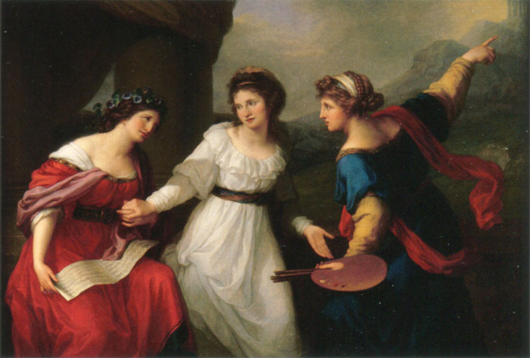
The Swiss-born Angelica Kauffman, most of whose prolific career was spent in Italy, combines allegory with portraiture in Angelica Hesitating between Music and Painting, 1791.
VIA WIKIMEDIA COMMONS
Another attempt to answer the question involves shifting the ground slightly and asserting, as some contemporary feminists do, that there is a different kind of “greatness” for women’s art than for men’s, thereby postulating the existence of a distinctive and recognizable feminine style, different both in its formal and its expressive qualities and based on the special character of women’s situation and experience.
This, on the surface of it, seems reasonable enough: in general, women’s experience and situation in society, and hence as artists, is different from men’s, and certainly the art produced by a group of consciously united and purposefully articulate women intent on bodying forth a group consciousness of feminine experience might indeed be stylistically identifiable as feminist, if not feminine, art. Unfortunately, though this remains within the realm of possibility it has so far not occurred. While the members of the Danube School, the followers of Caravaggio, the painters gathered around Gauguin at Pont-Aven, the Blue Rider, or the Cubists may be recognized by certain clearly defined stylistic or expressive qualities, no such common qualities of “femininity” would seem to link the styles of women artists generally, any more than such qualities can be said to link women writers, a case brilliantly argued, against the most devastating, and mutually contradictory, masculine critical clichés, by Mary Ellmann in her Thinking about Women.⁴ No subtle essence of femininity would seem to link the work of Artemesia Gentileschi, Mme. Vigée-Lebrun, Angelica Kauffmann, Rosa Bonheur, Berthe Morisot, Suzanne Valadon , Kaethe Kollwitz, Barbara Hepworth, Georgia O’Keeffe, Sophie Taeuber-Arp, Helen Frankenthaler, Bridget Riley, Lee Bontecou or Louise Nevelson, any more than that of Sappho, Marie de France, Jane Austen, Emily Brontë, George Sand, George Eliot, Virginia Woolf, Gertrude Stein, Anaïs Nin, Emily Dickinson, Sylvia Plath and Susan Sontag. In every instance, women artists and writers would seem to be closer to other artists and writers of their own period and outlook than they are to each other.
Women artists are more inward-looking, more delicate and nuanced in their treatment of their medium, it may be asserted. But which of the women artists cited above is more inward-turning than Redon, more subtle and nuanced in the handling of pigment than Corot? Is Fragonard more or less feminine than Mme. Vigée-Lebrun? Or is it not more a question of the whole Rococo style of 18th-century France being “feminine,” if judged in terms of a two-valued scale of “masculinity” vs. “femininity”? Certainly though, if daintiness, delicacy and preciousness are to be counted as earmarks of a feminine style, there is nothing fragile about Rosa Bonheur’s Horse Fair, nor dainty and introverted about Helen Frankenthaler’s giant canvases. If women have turned to scenes of domestiC life, or of children, so did Jan Steen, Chardin and the Impressionists—Renoir and Monet as well as Morisot and Cassatt. In any case, the mere choice of a certain realm of subject matter, or the restriction to certain subjects, is not to be equated with a style, much less with some sort of quintessentially feminine style.
The problem lies not so much with the feminists’ concept of what femininity is, but rather with their misconception—shared with the public at large—of what art is: with the naïve idea that art is the direct, personal expression of individual emotional experience, a translation of personal life into visual terms. Art is almost never that, great art never is. The making of art involves a self-consistent language of form, more or less dependent upon, or free from, given temporally-defined conventions, schemata or systems of notation, which have to be learned or worked out, either through teaching, apprenticeship or a long period of individual experimentation. The language of art is, more materially, embodied in paint and line on canvas or paper, in stone or clay or plastic or metal—it is neither a sob-story nor a confidential whisper.
The fact of the matter is that there have been no supremely great women artists, as far as we know, although there have been many interesting and very good ones who remain insufficiently investigated or appreciated; nor have there been any great Lithuanian jazz pianists, nor Eskimo tennis players, no matter how much we might wish there had been. That this should be the case is regrettable, but no amount of manipulating the historical or critical evidence will alter the situation; nor will accusations of male-chauvinist distortion of history. The fact, dear sisters, is that there are no women equivalents for Michelangelo or Rembrandt, Delacroix or Cézanne, Picasso or Matisse, or even, in very recent times, for de Kooning or Warhol, any more than there are Black American equivalents for the same. If there actually were large numbers of “hidden” great women artists, or if there really should be different standards for women’s art as opposed to men’s—and one can’t have it both ways—then what are the feminists fighting for? If women have in fact achieved the same status as men in the arts, then the status quo is fine as it is.
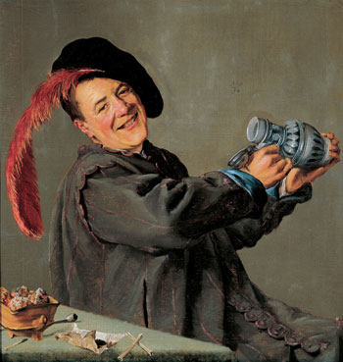
Judith Leyster’s The Jolly Toper was called a Frans Hal until the discovery of her typical signature, “J,” and the date 1629, in upper right center.
VIA WIKIMEDIA COMMONS
But in actuality, as we all know, things as they are and as they have been, in the arts as in a hundred other areas, are stultifying, oppressive and discouraging to all those, women among them, who did not have the good fortune to be born white, preferably middle class and, above all, male. The fault, dear brothers, lies not in our stars, our hormones, our menstrual cycles or our empty internal spaces, but in our institutions and our education—education understood to include everything that happens to us from the moment we enter this world of meaningful symbols, signs and signals. The miracle is, in fact, that given the overwhelming odds against women, or blacks, that so many of both have managed to achieve so much sheer excellence, in those bailiwicks of white masculine prerogative like science, politics or the arts.
It is when one really starts thinking about the implications of “Why have there been no great women artists?” that one begins to realize to what extent our consciousness of how things are in the world has been conditioned—and often falsified—by the way the most important questions are posed. We tend to take it for granted that there really is an East Asian Problem, a Poverty Problem, a Black Problem—and a Woman Problem. But first we must ask ourselves who is formulating these “questions,” and then, what purposes such formulations may serve. (We may, of course, refresh our memories with the connotations of the Nazi’s “Jewish Problem.”) Indeed, in our time of instant communication, “problems” are rapidly formulated to rationalize the bad conscience of those with power: thus the problem posed by Americans in Vietnam and Cambodia is referred to by Americans as “the East Asian Problem,” whereas East Asians may view it, more realistically, as “the American Problem”; the so-called Poverty Problem might more directly be viewed as the “Wealth Problem” by denizens of urban ghettos or rural wastelands; the same irony twists the White Problem into its opposite: a Black Problem; and the same inverse logic turns up in the formulation of our own present state of affairs as the “Woman Problem.”
Now the “Woman Problem,” like all human problems, so-called (and the very idea of calling anything to do with human beings a “problem” is, of course, a fairly recent one) is not amenable to “solution” at all, since what human problems involve is re-interpretation of the nature of the situation, or a radical alteration of stance or program on the part of the “problems” themselves. Thus women and their situation in the arts, as in other realms of endeavor, are not a “problem” to be viewed through the eyes of the dominant male power elite. Instead, women must conceive of themselves as potentially, if not actually, equal subjects, and must be willing to look the facts of their situation full in the face, without self-pity, or cop-outs; at the same time they must view their situation with that high degree of emotional and intellectual commitment necessary to create a world in which equal achievement will be not only made possible but actively encouraged by social institutions.
It is certainly not realistic to hope that a majority of men, in the arts, or in any other field, will soon see the light and find that it is in their own self-interest to grant complete equality to women, as some feminists optimistically assert, or to maintain that men themselves will soon realize that they are diminished by denying themselves access to traditionally “feminine” realms and emotional reactions. After all, there are few areas that are really “denied” to men, if the level of operations demanded be transcendent, responsible or rewarding enough: men who have a need for “feminine” involvement with babies or children gain status as pediatricians or child psychologists, with a nurse (female) to do the more routine work; those who feel the urge for kitchen creativity may gain fame as master chefs; and, of course, men who yearn to fulfill themselves through what are often termed “feminine” artistic interests can find themselves as painters or sculptors, rather than as volunteer museum aides or part time ceramists, as their female counterparts so often end up doing; as far as scholarship is concerned, how many men would be willing to change their jobs as teachers and researchers for those of unpaid, part-time research assistants and typists as well as full-time nannies and domestic workers?
Those who have privileges inevitably hold on to them, and hold tight, no matter how marginal the advantage involved, until compelled to bow to superior power of one sort or another.
Thus the question of women’s equality—in art as in any other realm—devolves not upon the relative benevolence or ill-will of individual men, nor the self-confidence or abjectness of individual women, but rather on the very nature of our institutional structures themselves and the view of reality which they impose on the human beings who are part of them. As John Stuart Mill pointed out more than a century ago: “Everything which is usual appears natural. The subjection of women to men being a universal custom, any departure from it quite naturally appears unnatural.”⁵ Most men, despite lip-service to equality, are reluctant to give up this “natural” order of things in which their advantages are so great; for women, the case is further complicated by the fact that, as Mill astutely pointed out, unlike other oppressed groups or castes, men demand of her not only submission but unqualified affection as well; thus women are often weakened by the internalized demands of the male-dominated society itself, as well as by a plethora of material goods and comforts: the middle-class woman has a great deal more to lose than her chains.
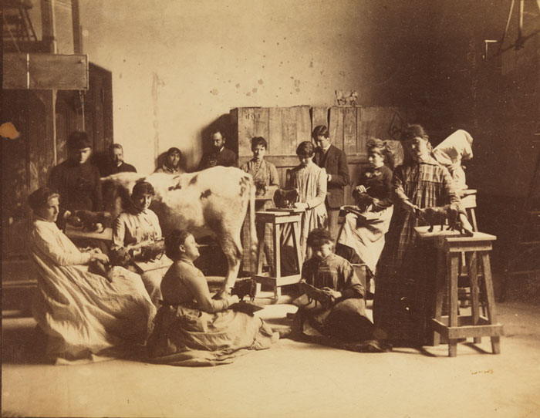
At Thomas Eakins’ life-class at the Pennsylvania Academy around 1855, a cow, instead of a nude man, served as a model for the women students.
COURTESY PENNSYLVANIA ACADEMY OF THE FINE ARTS/CHARLES BREGLER’S THOMAS EAKINS COLLECTION, PURCHASED WITH THE PARTIAL SUPPORT OF THE PEW MEMORIAL TRUST
The question “Why have there been no great women artists?” is simply the top tenth of an iceberg of misinterpretation and misconception; beneath lies a vast dark bulk of shaky idées reçues about the nature of art and its situational concomitants, about the nature of human abilities in general and of human excellence in particular, and the role that the social order plays in all of this. While the “woman problem” as such may be a pseudo-issue, the misconceptions involved in the question “Why have there been no great women artists?” points to major areas of intellectual obfuscation beyond the specific political and ideological issues involved in the subjection of women. Basic to the question are many naïve, distorted, uncritical assumptions about the making of art in general, as well as the making of great art. These assumptions, conscious or unconscious, link together such unlikely superstars as Michelangelo and van Gogh, Raphael and Jackson Pollock under the rubric of “Great”—an honorific attested to by the number of scholarly monographs devoted to the artist in question—and the Great Artist is, of course, conceived of as one who has “Genius”; Genius, in turn, is thought of as an atemporal and mysterious power somehow embedded in the person of the Great Artist.⁶ Such ideas are related to unquestioned, often unconscious, meta-historical premises that make Hippolyte Taine’s race-milieu-moment formulation of the dimensions of historical thought seem a model of sophistication. But these assumptions are intrinsic to a great deal of art-historical writing. It is no accident that the crucial question of the conditions generally productive of great art has so rarely been investigated, or that attempts to investigate such general problems have, until fairly recently, been dismissed as unscholarly, too broad, or the province of some other discipline, like sociology. To encourage a dispassionate, impersonal, sociological and institutionally-oriented approach would reveal the entire romantic, elitist, individual-glorifying and monograph-producing substructure upon which the profession of art history is based, and which has only recently been called in to question by a group of younger dissidents.
Underlying the question about woman as artist, then, we find the myth of the Great Artist—subject of a hundred monographs, unique, godlike—bearing within his person since birth a mysterious essence, rather like the golden nugget in Mrs. Grass’s chicken soup, called Genius or Talent, which, like murder, must always out, no matter how unlikely or unpromising the circumstances.
The magical aura surrounding the representational arts and their creators has, of course, given birth to myths since the earliest times. Interestingly enough, the same magical abilities attributed by Pliny to the Greek sculptor Lysippos in antiquity—the mysterious inner call in early youth, the lack of any teacher but Nature herself—is repeated as late as the 19th century by Max Buchon in his biography of Courbet. The supernatural powers of the artist as imitator, his control of strong, possibly dangerous powers, have functioned historically to set him off from others as a godlike creator, one who creates Being out of nothing. The fairy tale of the Boy Wonder, discovered by an older artist or discerning patron, usually in the guise of a lowly shepherd boy, has been a stock-in-trade of artistic mythology ever since Vasari immortalized the young Giotto, discovered by the great Cimabue while the lad was guarding his flocks, drawing sheep on a stone; Cimabue, overcome with admiration by the realism of the drawing, immediately invited the humble youth to be his pupil.⁷ Through some mysterious coincidence, later artists including Beccafumi, Andrea Sansovino, Andrea del Castagno, Mantegna, Zurbaran and Goya were all discovered in similar pastoral circumstances. Even when the young Great Artist was not fortunate enough to come equipped with a flock of sheep, his talent always seems to have manifested itself very early, and independent of any external encouragement: Filippo Lippi and Poussin, Courbet and Monet are all reported to have drawn caricatures in the margins of their schoolbooks instead of studying the required subjects—we never, of course, hear about the youths who neglected their studies and scribbled in the margins of their notebooks without ever becoming anything more elevated than department-store clerks or shoe salesmen. The great Michelangelo himself, according to his biographer and pupil, Vasari, did more drawing than studying as a child. So pronounced was his talent, reports Vasari, that when his master, Ghirlandaio, absented himself momentarily from his work in Santa Maria Novella, and the young art student took the opportunity to draw “the scaffolding, trestles, pots of paint, brushes and the apprentices at their tasks” in this brief absence, he did it so skillfully that upon his return the master exclaimed: “This boy knows more than I do.”
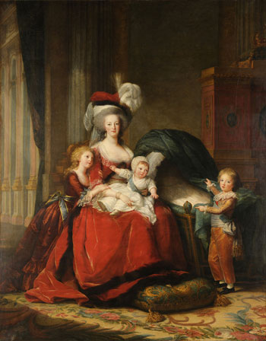
Elisabeth Vigée-Lebrun’s immense following at the French court was largely due to the patronage of Marie-Antoinette, whom she has been credited with making sympathetic to posterity through her portraits of the queen. Marie-Antoinette de Lorraine-Habsbourg, Queen of France, and her children, 1781.
VIA WIKIMEDIA COMMONS
As is so often the case, such stories, which probably have some truth in them, tend both to reflect and perpetuate the attitudes they subsume. Despite any basis in fact of these myths about the early manifestations of Genius, the tenor of the tales is misleading. It is no doubt true, for example, that the young Picasso passed all the examinations for entrance to the Barcelona, and later to the Madrid, Academy of Art at the age of 15 in but a single day, a feat of such difficulty that most candidates required a month of preparation. But one would like to find out more about similar precocious qualifiers for art academies who then went on to achieve nothing but mediocrity or failure—in whom, of course, art historians are uninterested—or to study in greater detail the role played by Picasso’s art-professor father in the pictorial precocity of his son. What if Picasso had been born a girl? Would Señor Ruiz have paid as much attention or stimulated as much ambition for achievement in a little Pablita?
What is stressed in all these stories is the apparently miraculous, non-determined and a-social nature of artistic achievement; this semi-religious conception of the artist’s role is elevated to hagiography in the 19th-century, when both art historians, critics and, not least, some of the artists themselves tended to elevate the making of art into a substitute religion, the last bulwark of Higher Values in a materialistic world. The artist, in the 19th-century Saints’ Legend, struggles against the most determined parental and social opposition, suffering the slings and arrows of social opprobrium like any Christian martyr, and ultimately succeeds against all odds—generally, alas, after his death—because from deep within himself radiates that mysterious, holy effulgence: Genius. Here we have the mad van Gogh, spinning out sunflowers despite epileptic seizures and near-starvation; Cézanne, braving paternal rejection and public scorn in order to revolutionize painting; Gauguin throwing away respectability and financial security with a single existential gesture to pursue his Calling in the tropics, or Toulouse-Lautrec, dwarfed, crippled and alchoholic [sic], sacrificing his aristocratic birthright in favor of the squalid surroundings that provided him with inspiration, etc.
Now no serious contemporary art historian takes such obvious fairy tales at their face value. Yet it is this sort of mythology about artistic achievement and its concomitants which forms the unconscious or unquestioned assumptions of scholars, no matter how many crumbs are thrown to social influences, ideas of the times, economic crises and so on. Behind the most sophisticated investigations of great artists—more specifically, the art-historical monograph, which accepts the notion of the Great Artist as primary, and the social and institutional structures within which he lived and worked as mere secondary “influences” or “background”—lurks the golden-nugget theory of genius and the free-enterprise conception of individual achievement. On this basis, women’s lack of major achievement in art may be formulated as a syllogism: If women had the golden nugget of artistic genius then it would reveal itself. But it has never revealed itself. Q.E.D. Women do not have the golden nugget of artistic genius. If Giotto, the obscure shepherd boy, and van Gogh with his fits could make it, why not women?
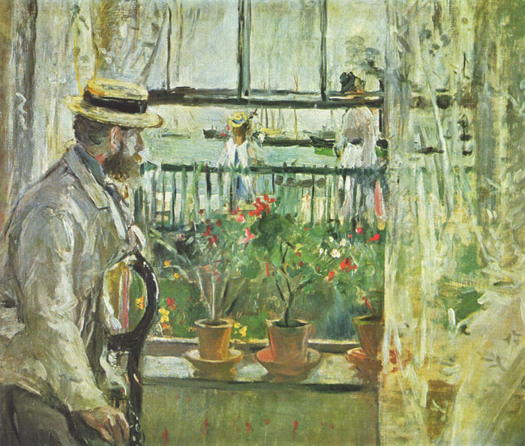
Berthe Morisot was a close friend of Manet and later married his brother. Eugene Manet on the Isle of Wight, 1875.
VIA WIKIMEDIA COMMONS
Yet as soon as one leaves behind the world of fairy-tale and self-fulfilling prophecy and, instead, casts a dispassionate eye on the actual situations in which important art production has existed, in the total range of its social and institutional structures throughout history, one finds that the very questions which are fruitful or relevant for the historian to ask shape up rather differently. One would like to ask, for instance, from what social classes artists were most likely to come at different periods of art history, from what castes and sub-group. What proportion of painters and sculptors, or more specifically, of major painters and sculptors, came from families in which their fathers or other close relatives were painters and sculptors or engaged in related professions? As Nikolaus Pevsner points out in his discussion of the French Academy in the 17th and 18th centuries, the transmission of the artistic profession from father to son was considered a matter of course (as it was with the Coypels, the Coustous, the Van Loos, etc); indeed, sons of academicians were exempted from the customary fees for lessons.⁸ Despite the noteworthy and dramatically satisfying cases of the great father-rejecting révoltés of the 19th century, one might be forced to admit that a large proportion of artists, great and not-so-great, in the days when it was normal for sons to follow in their fathers’ footsteps, had artist fathers. In the rank of major artists, the names of Holbein and Dürer, Raphael and Bernini, immediately spring to mind; even in our own times, one can cite the names of Picasso, Calder, Giacometti and Wyeth as members of artist-families.
As far as the relationship of artistic occupation and social class is concerned, an interesting paradigm for the question “Why have there been no great women artists?” might well be provided by trying to answer the question: “Why have there been no great artists from the aristocracy?” One can scarcely think, before the anti-traditional 19th century at least, of any artist who sprang from the ranks of any more elevated class than the upper bourgeoisie; even in the 19th century, Degas came from the lower nobility—more like the haute bourgeoisie, in fact—and only Toulouse-Lautrec, metamorphosed into the ranks of the marginal by accidental deformity, could be said to have come from the loftier reaches of the upper classes. While the aristocracy has always provided the lion’s share of the patronage and the audience for art—as, indeed, the aristocracy of wealth does even in our more democratic days—it has contributed little beyond amateurish efforts to the creation of art itself, despite the fact that aristocrats (like many women) have had more than their share of educational advantages, plenty of leisure and, indeed, like women, were often encouraged to dabble in the arts and even develop into respectable amateurs, like Napoleon III’s cousin, the Princess Mathilde, who exhibited at the official Salons, or Queen Victoria, who, with Prince Albert, studied art with no less a figure than Landseer himself. Could, it be that the little golden nugget—Genius—is missing from the aristocratic make-up in the same way that it is from the feminine psyche? Or rather, is it not, that the kinds of demands and expectations placed before both aristocrats and women—the amount of time necessarily devoted to social functions, the very kinds of activities demanded—simply made total devotion to professional art production out of the question, indeed unthinkable, both for upper-class males and for women generally, rather than its being a question of genius and talent?
When the right questions are asked about the conditions for producing art, of which the production of great art is a sub-topic, there will no doubt have to be some discussion of the situational concomitants of intelligence and talent generally, not merely of artistic genius. Piaget and others have stressed in their genetic epistemology that in the development of reason and in the unfolding of imagination in young children, intelligence—or, by implication, what we choose to call genius—is a dynamic activity rather than a static essence, and an activity of a subject in a situation. As further investigations in the field of child development imply, these abilities, or this intelligence, are built up minutely, step by step, from infancy onward, and the patterns of adaptation-accommodation may be established so early within the subject-in-an-environment that they may indeed appear to be innate to the unsophisticated observer. Such investigations imply that, even aside from meta-historical reasons, scholars will have to abandon the notion, consciously articulated or not, of individual genius as innate, and as primary to the creation of art.⁹
The question “Why have there been no great women artists?” has led us to the conclusion, so far, that art is not a free, autonomous activity of a super-endowed individual, “influenced” by previous artists, and, more vaguely and superficially, by “social forces,” but rather, that the total situation of art making, both in terms of the development of the art maker and in the nature and quality of the work of art itself, occur in a social situation, are integral elements of this social structure, and are mediated and determined by specific and definable social institutions, be they art academies, systems of patronage, mythologies of the divine creator, artist as he-man or social outcast.
The Question of the Nude
We can now approach our question from a more reasonable standpoint, since it seems probable that the answer to why there have been no great women artists lies not in the nature of individual genius or the lack of it, but in the nature of given social institutions and what they forbid or encourage in various classes or groups of individuals.
Let us first examine such a simple, but critical, issue as availability of the nude model to aspiring women artists, in the period extending from the Renaissance until near the end of the 19th century, a period in which careful and prolonged study of the nude model was essential to the training of every young artist, to the production of any work with pretentions to grandeur, and to the very essence of History Painting, generally accepted as the highest category of art: indeed, it was argued by defenders of traditional painting in the 19th century that there could be no great painting with clothed figures, since costume inevitably destroyed both the temporal universality and the classical idealization required by great art. Needless to say, central to the training programs of the academies since their inception late in the 16th and early in the 17th centuries, was life drawing from the nude, generally male, model. In addition, groups of artists and their pupils often met privately for life drawing sessions from the nude model in their studios. In general, it might be added, while individual artists and private academies employed the female model extensively, the female nude was forbidden in almost all public art schools as late as 1850 and after—a state of affairs which Pevsner rightly designates as “hardly believable.”¹⁰ Far more believable, unfortunately, was the complete unavailability to the aspiring woman artist of any nude models at all, male or female. As late as 1893, “lady” students were not admitted to life drawing at the Royal Academy in London, and even when they were, after that date, the model had to be “partially draped.”¹¹
A brief survey of representations of life-drawing sessions reveals: an all male clientele drawing from the female nude in Rembrandt’s studio; men working from male nudes in 18th-century representations of academic instruction in The Hague and Vienna; men working from the seated male nude in Bailly’s charming painting of the interior of Houdon’s studio at the beginning of the 19th century; Mathieu Cochereau’s scrupulously veristic Interior of David’s Studio, exhibited in the Salon of 1814, reveals a group of young men diligently drawing or painting from a male nude model, whose discarded shoes may be seen before the models’ stand.
The very plethora of surviving “Academies”—detailed, painstaking studies from the nude studio model—in the youthful oeuvre of artists down through the time of Seurat and well into the 20th century, attests to the central importance of this branch of study in the pedagogy and development of the talented beginner. The formal academic program itself normally proceeded, as a matter of course,
from copying from drawings and engravings, to drawing from casts of famous works of sculpture, to drawing from the living model. To be deprived of this ultimate stage of training meant, in effect, to be deprived of the possibility of creating major art works, unless one were a very ingenious lady indeed, or simply, as most of the women aspiring to be painters ultimately did, to restrict oneself to the “minor” fields of portraiture, genre, landscape or still-life. It is rather as though a medical student were denied the opportunity to dissect or even examine the naked human body.
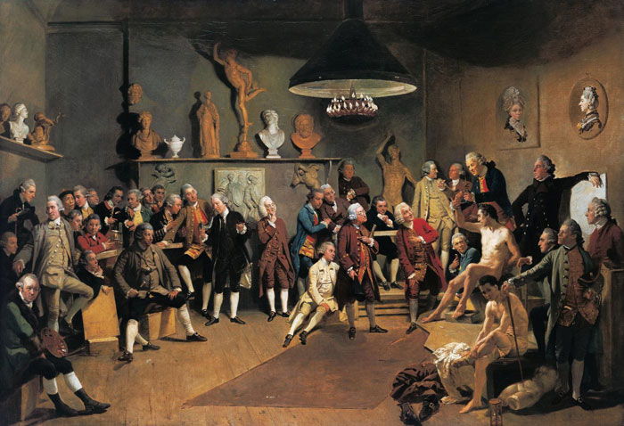
In Zoffany’s painting of the life-class at the Royal Academy, 1772, all the members are present except for Angelica Kauffmann, who for reasons of propriety has a stand-in—her portrait on the wall.
VIA WIKIMEDIA COMMONS
There exist, to my knowledge, no representations of artists drawing from the nude model which include women in any role but that of the nude model itself, an interesting commentary on rules of propriety: i.e., it is all right for a (“low,” of course) woman to reveal herself naked-as-an-object for a group of men, but forbidden to a woman to participate in the active study and recording of naked-man-as-an-object, or even of a fellow woman. An amusing example of this taboo on confronting a dressed lady with a naked man is embodied in a group portrait of the members of the Royal Academy in London in 1772, represented by Zoffany as gathered in the life room before two nude male models: all the distinguished members are present with but one noteworthy exception—the single female member, the renowned Angelica Kauffmann, who, for propriety’s sake, is merely present in effigy, in the form of a portrait hanging on the wall. A slightly earlier drawing of Ladies in the Studio by the Polish artist Daniel Chodowiecki, shows the ladies portraying a modestly dressed member of their sex. In a lithograph dating from the relatively liberated epoch following the French Revolution, the lithographer Marlet has represented some women sketchers in a group of students working from the male model, but the model himself has been chastely provided with what appears to be a pair of bathing trunks, a garment hardly conducive to a sense of classical elevation: no doubt such license was considered daring in its day, and the young ladies in question suspected of doubtful morals, but even this liberated state of affairs seems to have lasted only a short while. In an English stereoscopic color view of the interior of a studio of about 1865, the standing, bearded male model is so heavily draped that not an iota of his anatomy escapes from the discreet toga, save for a single bare shoulder and arm: even so, he obviously had the grace to avert his eyes in the presence of the crinoline-clad young sketchers.
The women in the Women’s Modeling Class at the Pennsylvania Academy were evidently not allowed even this modest privilege. A photograph by Thomas Eakins of about 1885 reveals these students modeling from a cow (bull? ox? the nether regions are obscure in the photograph), a naked cow to be sure, perhaps a daring liberty when one considers that even piano legs might be concealed beneath pantalettes during this era (the idea of introducing a bovine model into the artist’s studio stems from Courbet, who brought a bull into his short-lived studio academy in the 1860s). Only at the very end of the 19th century, in the relatively liberated and open atmosphere of Repin’s studio and circle in Russia, do we find representations of women art students working uninhibitedly from the nude—the female model, to be sure—in the company of men. Even in this case, it must be noted that certain photographs represent a private sketch group meeting in one of the women artists’ homes; in the other, the model is draped; and the large group portrait, a co-operative effort by two men and two women students of Repin’s, is an imaginary gathering together of all of the Russian realist’s pupils, past and present, rather than a realistic studio view.
I have gone into the question of the availability of the nude model, a single aspect of the automatic, institutionally-maintained discrimination against women, in such detail simply to demonstrate both the universality of the discrimination against women and its consequences, as well as the institutional rather than individual nature of but one facet of the necessary preparation for achieving mere proficiency, much less greatness, in the realm of art during a long stretch of time. One could equally well examine other dimensions of the situation, such as the apprenticeship system, the academic educational pattern which, in France especially, was almost the only key to success and which had a regular progression and set competitions, crowned by the Prix de Rome which enabled the young winner to work in the French Academy in that city—unthinkable for women, of course—and for which women were unable to compete until the end of the 19th century, by which time, in fact, the whole academic system had lost its importance anyway. It seems clear, to take France in the 19th century as an example, a country which probably had a larger proportion of women artists than any other—that is to say, in terms of their percentage in the total number of artists exhibiting in
the Salon—that “women were not accepted as professional painters.”¹² In the middle of the century, there were only a third as many women as men artists, but even this mildly encouraging statistic is deceptive when we discover that out of this relatively meager number, none had attended that major stepping stone to artistic success, the Ecole des Beaux-Arts, only 7 percent had received any official commission or had held any official office—and these might include the most menial sort of work—only 7 percent had ever received any Salon medal, and none had ever received the Legion of Honor.¹³ Deprived of encouragements, educational facilities and rewards, it is almost incredible that a certain percentage of women did persevere and seek a profession in the arts.
It also becomes apparent why women were able to compete on far more equal terms with men—and even become innovators—in literature. While art-making traditionally has demanded the learning of specific techniques and skills, in a certain sequence, in an institutional setting outside the home, as well as becoming familiar with a specific vocabulary of iconography and motifs, the same is by no means true for the poet or novelist. Anyone, even a women, has to learn the language, can learn to read and write, and can commit personal experiences to paper in the privacy of one’s room. Naturally this oversimplifies the real difficulties and complexities involved in creating good or great literature, whether by man or woman, but it still gives a clue as to the possibility of the existence of Emily Brönte or an Emily Dickinson, and the lack of their counterparts, at least until quite recently, in the visual arts.
Of course we have not gone into the “fringe” requirements for major artists, which would have been, for the most part, both psychically and socially closed to women, even if hypothetically they could have achieved the requisite grandeur in the performance of their craft: in the Renaissance and after, the great artist, aside from participating in the affairs of an academy, might well be intimate
with members of humanist circles with whom he could exchange ideas, establish suitable relationships with patrons, travel widely and freely, perhaps politic and intrigue; nor have we mentioned the sheer organizational acumen and ability involved in running a major studio-factory, like that of Rubens. An enormous amount of self-confidence and worldly knowledgeability, as well as a natural sense of well-earned dominance and power, was needed by the great chef d’école, both in the running of the production end of painting, and in the control and instruction of the numerous students and assistants.
The Lady’s Accomplishment
In contrast to the single-mindedness and commitment demanded of a chef d’école, we might set the image of the “lady painter” established by 19th-century etiquette books and reinforced by the literature of the times. It is precisely the insistence upon a modest, proficient, self-demeaning level of amateurism as a “suitable accomplishment” for the well-brought up young woman, who naturally would want to direct her major attention to the welfare of others—family and husband—that militated, and still militates, against any real accomplishment on the part of women. It is this emphasis which transforms serious commitment to frivolous self-indulgence, busy work or occupational therapy, and today, more than ever, in suburban bastions of the feminine mystique, tends to distort the whole notion of what art is and what kind of social role it plays. In Mrs. Ellis’ widely read The Family Monitor and Domestic Guide, published before the middle of the 19th century, a book of advice popular both in the United States and in England, women were warned against the snare of trying too hard to excel in any one thing:
It must not be supposed that the writer is one who would advocate, as essential to woman, any very extraordinary degree of intellectual attainment, especially if confined to one particular branch of study. “I should like to excel in something” is a frequent and, to some extent, laudable expression; but in what does it originate, and to what does it tend? To be able to do a great many things tolerably well, is of infinitely more value to a woman, than to be able to excel in any one. By the former, she may render herself generally useful: by the latter, she may dazzle for an hour. By being apt, and tolerably well skilled in everything, she may fall into any situation in life with dignity and ease—by devoting her time to excellence in one, she may remain incapable of every other.
So far as cleverness, learning, and knowledge are conducive to woman’s moral excellence, they are therefore desirable, and no further. All that would occupy her mind to the exclusion of better things, all that would involve her in the mazes of flattery and admiration, all that would tend to draw away her thoughts from others and fix them on herself, ought to be avoided as an evil to her, however brilliant or attractive it may be in itself.¹⁴
Lest we are tempted to laugh, we may refresh ourselves with more recent samples of exactly the same message cited in Betty Friedan’s Feminine Mystique, or in the pages of recent issues of popular women’s magazines.
This advice has a familiar ring, of course: propped up by a bit of Freudianism and some tag-lines from the social sciences about the well-rounded personality, preparation for woman’s chief career, marriage, and the unfemininity of deep involvement with work rather than sex, it is still the mainstay of the Feminine Mystique. Such an outlook helps guard man from unwanted competition in his “serious” professional activities and assures him of “well-rounded” assistance on the home front, so that he may have sex and family in addition to the fulfillment of his own specialized talent and excellence at the same time.
As far as painting specifically is concerned, Mrs. Ellis finds that it has one immediate advantage for the young lady over its rival branch of artistic activity, music—it is quiet and disturbs no one (this negative virtue, of course, would not be true of sculpture, but accomplishment with the hammer and chisel simply never occurs as a suitable accomplishment for the weaker sex); in addition, says Mrs. Ellis, “it [drawing] is an employment which beguiles the mind of many cares…Drawing is, of all other occupations, the one most calculated to keep the mind from brooding upon self, and to maintain
that general cheerfulness which is a part of social and domestic duty…It can also,” she adds, “be laid down and resumed, as circumstance or inclination may direct, and that without any serious loss.”¹⁵ Again, lest we feel that we have made a great deal of progress in this area in the past 100 years, I might bring up the remark of a bright young doctor who, when the conversation turned to his wife and her friends “dabbling” in the arts, snorted: “Well, at least it keeps them out of trouble!” Now as in the 19th century, amateurism and lack of real commitment as well as snobbery and emphasis on chic on the part of women in their artistic “hobbies,” feeds the contempt of the successful, professionally committed man who is engaged in “real” work and can, with a certain justice, point to his wife’s lack of seriousness in her artistic activities. For such men, the “real” work of women is only that which directly or indirectly serves the family; any other commitment falls under the rubric of diversion, selfishness, egomania or, at the unspoken extreme, castration. The circle is a vicious one, in which philistinism and frivolity mutually re-enforce each other.
In literature, as in life, even if the woman’s commitment to art was a serious one, she was expected to drop her career and give up this commitment at the behest of love and marriage: this lesson is, today as in the 19th century, still inculcated in young girls, directly or indirectly, from the moment they are born. Even the determined and successful heroine of Mrs. Craik’s mid-19th-century novel about feminine artistic success, Olive, a young woman who lives alone, strives for fame and independence and actually supports herself through her art—such unfeminine behavior is at least partly excused by the fact that she is a cripple and automatically considers that marriage is denied to her—even Olive ultimately succumbs to the blandishments of love and marriage. To paraphrase the words of Patricia Thomson in The Victorian Heroine, Mrs. Craik, having shot her bolt in the course of her novel, is content, finally, to let her heroine, whose ultimate greatness the reader has never been able to doubt, sink gently into matrimony. “Of Olive, Mrs. Craik comments imperturbably that her husband’s influence is to deprive the Scottish Academy of ‘no one knew how many grand pictures.’ ”¹⁶ Then as now, despite men’s greater “tolerance,” the choice for women seems always to be marriage or a career, i.e., solitude as the price of success or sex and companionship at the price of professional renunciation.
That achievement in the arts, as in any field of endeavor, demands struggle and sacrifice, no one would deny; that this has certainly been true after the middle of the 19th century, when the traditional institutions of artistic support and patronage no longer fulfilled their customary obligations, is undeniable: one has only to think of Delacroix, Courbet, Degas, van Gogh and Toulouse-Lautrec as examples of great artists who gave up the distractions and obligations of family life, at least in part, so that they could pursue their artistic careers more singlemindedly. Yet none of them was automatically denied the pleasures of sex or companionship on account of this choice. Nor did they ever conceive that they had sacrificed their manhood or their sexual role on account of their singleness and singlemindedness in order to achieve professional fulfillment. But if the artist in question happens to be a woman, 1,000 years of guilt, self-doubt and objecthood have been added to the undeniable difficulties of being an artist in the modern world.
The unconscious aura of titillation that arises from a visual representation of an aspiring woman artist in the mid-19th century, Emily Mary Osborne’s heartfelt painting, Nameless and Friendless, 1857, a canvas representing a poor but lovely and respectable young girl at a London art dealer, nervously awaiting the verdict of the pompous proprietor about the worth of her canvases while two ogling “art lovers” look on, is really not too different in its underlying assumptions from an overtly salacious work like Bompard’s Debut of the Model. The theme in both is innocence, delicious feminine innocence, exposed to the world. It is the charming vulnerability of the young woman artist, like that of the hesitating model, which is really the subject of Miss Osborne’s painting, not the value of the young woman’s work or her pride in it: the issue here is, as usual, sexual rather than serious. Always a model but never an artist might well have served as the motto of the seriously aspiring young woman in the arts of the 19th century.
Successes
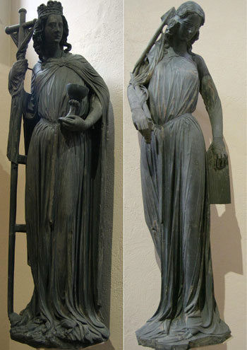
The monumental figures of The Church and The Synagogue from the South Portal of the Cathedral of Strasbourg, ca. 1225, are attributed to Sabina von Steinbach, daughter of the master-sculptor of the cathedral, who died before the completion of the work.
VIA WIKIMEDIA COMMONS
But what of the small band of heroic women, who, throughout the ages, despite obstacles, have achieved pre-eminence, if not the pinnacles of grandeur of a Michelangelo, a Rembrandt or a Picasso? Are there any qualities that may be said to have characterized them as a group and as individuals? While we cannot go into such an investigation in depth in this article, we can point to a few striking characteristics of women artists generally: they all, almost without exception, were either the daughters of artist fathers, or, generally later, in the 19th and 20th centuries, had a close personal connection with a stronger or more dominant male artistic personality. Neither of these characteristics is, of course, unusual for men artists, either, as we have indicated above in the case of artist fathers and sons: it is simply true almost without exception for their feminine counterparts, at least until quite recently. From the legendary sculptor, Sabina von Steinbach, in the 13th century, who, according to local tradition, was responsible for South Portal groups on the Cathedral of Strasbourg, down to Rosa Bonheur, the most renowned animal painter of the 19th century, and including such eminent women artists as Marietta Robusti, daughter of Tintoretto, Lavinia Fontana, Artemisia Gentileschi, Elizabeth Chéron, Mme. Vigée-Lebrun and Angelica Kauffmann—all, without exception, were the daughters of artists; in the 19th century, Berthe Morisot was closely associated with Manet, later marrying his brother, and Mary Cassatt based a good deal of her work on the style of her close friend Degas. Precisely the same breaking of traditional bonds and discarding of time-honored practices that permitted men artists to strike out in directions quite different from those of their fathers in the second half of the 19th century enabled women, with additional difficulties, to be sure, to strike out on their own as well. Many of our more recent women artists, like Suzanne Valadon, Paula Modersohn-Becker, Kaethe Kollwitz or Louise Nevelson, have come from non-artistic backgrounds, although many contemporary and near-contemporary women artists have married fellow artists.
It would be interesting to investigate the role of benign, if not outright encouraging, fathers in the formation of women professionals: both Kaethe Kollwitz and Barbara Hepworth, for example, recall
the influence of unusually sympathetic and supportive fathers on their artistic pursuits. In the absence of any thoroughgoing investigation, one can only gather impressionistic data about the presence or absence of rebellion against parental authority in women artists, and whether there may be more or less rebellion on the part of women artists than is true in the case of men or vice versa. One thing however is clear: for a woman to opt for a career at all, much less for a career in art, has required a certain amount of unconventionality, both in the past and at present; whether or not the woman artist rebels against or finds strength in the attitude of her family, she must in any case have a good strong streak of rebellion in her to make her way in the world of art at all, rather than submitting to the socially approved role of wife and mother, the only role to which every social institution consigns her automatically. It is only by adopting, however covertly, the “masculine” attributes of singlemindedness, concentration, tenaciousness and absorption in ideas and craftsmanship for their own sake, that women have succeeded, and continue to succeed, in the world of art.
Rosa Bonheur
It is instructive to examine in greater detail one of the most successful and accomplished women painters of all time, Rosa Bonheur (1822-1899), whose work, despite the ravages wrought upon its estimation by changes of taste and a certain admitted lack of variety, still stands as an impressive achievement to anyone interested in the art of the 19th century and in the history of taste generally. Rosa Bonheur is a woman artist in whom, partly because of the magnitude of her reputation, all the various conflicts, all the internal and external contradictions and struggles typical of her sex and profession, stand out in sharp relief.
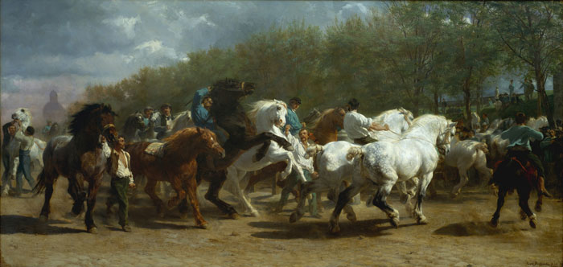
Like Constant Troyon, Bonheur aimed at an epical, “heroic” interpretation of animals which became extremely popular. The Horse Fair, ca. 1852–55.
The success of Rosa Bonheur firmly establishes the role of institutions, and institutional change, as a necessary, if not a sufficient cause of achievement in art. We might say that Bonheur picked a fortunate time to become an artist if she was, at the same time, to have the disadvantage of being a woman: she came into her own in the middle of the 19th century, a time in which the struggle between traditional History Painting as opposed to the less pretentious and more free-wheeling genre painting, landscape and still-life was won by the latter group hands down. A major change in the social and institutional support for art itself was well under way: with the rise of the bourgeoisie and the fall of the cultivated aristocracy, smaller paintings, generally of every-day subjects, rather than grandiose mythological or religious scenes were much in demand. To cite the Whites: “Three hundred provincial museums there might be, government commissions for public works there might be, but the only possible paid destinations for t he rising flood of canvases were the homes of the bourgeoisie. History painting had not and never would rest comfortably in the middle-class parlor. ‘Lesser’ forms of image art—genre, landscape, still-life—did.”¹⁷ In mid-century France, as in 17th-century Holland, there was a tendency for artists to attempt to achieve some sort of security in a shaky market situation by specializing, by making a career out of a specific subject: animal painting was a very popular field, as the Whites point out, and Rosa Bonheur was no doubt its most accomplished and successful practitioner, followed in popularity only by the Barbizon painter Troyon (who at one time was so pressed for his paintings of cows that he hired another artist to brush in the backgrounds). Rosa Bonheur’s rise to fame accompanied that of the Barbizon landscapists, supported by those canny dealers, the Durand-Ruels, who later moved on to the Impressionists. The
Durand-Ruels were among the first dealers to tap the expanding market in movable decoration for the middle classes, to use the Whites’ terminology. Rosa Bonheur’s naturalism and ability to capture the individuality—even the “soul”—of each of her animal subjects coincided with bourgeois taste at the time. The same combination, of qualities, with a much stronger dose of sentimentality and pathetic fallacy to be sure, likewise assured the success of her animalier contemporary, Landseer, in England.
Daughter of an impoverished drawing master, Rosa Bonheur quite naturally showed her interest in art early; at the same time, she exhibited an independence of spirit and liberty of manner which immediately earned her the label of tomboy. According to her own later accounts, her “masculine protest” established itself early; to what extent any show of persistence, stubbornness and vigor would be counted as “masculine” in the first half of the 19th century is conjectural. Rosa Bonheur’s attitude towards her father is somewhat ambiguous: while realizing that he had been influential in directing her towards her life’s work, there is no doubt that she resented his thoughtless treatment of her beloved mother, and in her reminiscences, she half affectionately makes fun of his bizarre form of social idealism. Raimond Bonheur had been an active member of the short-lived Saint-Simonian community, established in the third decade of the 19th century by “Le Père” Enfantin at Menilmontant. Although in her later years Rosa Bonheur might have made fun of some of the more far-fetched eccentricities of the members of the community, and disapproved of the additional strain which her father’s apostolate placed on her overburdened mother, it is obvious that the Saint-Simonian ideal of equality for women—they disapproved of marriage, their trousered feminine costume was a token of emancipation, and their spiritual leader, Le Père Enfantin, made extraordinary efforts to find a Woman Messiah to share his reign—made a strong impression on her as a child, and may well have influenced her future course of behavior.
“Why shouldn’t I be proud to be a woman?” she exclaimed to an interviewer. “My father, that enthusiastic apostle of humanity, many times reiterated to me that woman’s mission was to elevate the human race, that she was the Messiah of future centuries. It is to his doctrines that I owe the great, noble ambition I have conceived for the sex which I proudly affirm to be mine, and whose independence I will support to my dying day…”¹⁸ When she was hardly more than a child, he instilled in her the ambition to surpass Mme. Vigée-Lebrun certainly the most eminent model she could be expected to follow, and he gave her early efforts every possible encouragement. At the same time, the spectacle of her uncomplaining mother’s slow decline from sheer overwork and poverty might have been an even more realistic influence on her decision to control her own destiny and never to become the slave of a husband and children. What is particularly interesting from the modern feminist viewpoint is Rosa Bonheur’s ability to combine the most vigorous and unapologetic masculine protest with unabashedly self-contradictory assertions of “basic” femininity.
In those refreshingly straightforward pre-Freudian days, Rosa Bonheur could explain to her biographer that she had never wanted to marry for fear of losing her independence—too many young girls let themselves be led to the altar like lambs to the sacrifice, she maintained. Yet at the same time that she rejected marriage for herself and implied an inevitable loss of selfhood for any woman who engaged in it, she, unlike the Saint-Simonians, considered marriage “a sacrament indispensable to the organization of society.”
While remaining cool to offers of marriage, she joined in a seemingly cloudless, lifelong and apparently Platonic union with a fellow woman artist, Nathalie Micas, who evidently provided her with the companionship and emotional warmth which she needed. Obviously the presence of this sympathetic friend did not seem to demand the same sacrifice of genuine commitment to her profession which marriage would have entailed: in any case, the advantages of such an arrangement for women who wished to avoid the distraction of children in the days before reliable contraception are obvious.
Yet at the same time that she frankly rejected the conventional feminine role of her times, Rosa Bonheur still was drawn into what Betty Friedan has called the “frilly blouse syndrome,” that innocuous version of the feminine protest which even today compels successful women psychiatrists or professors to adopt some ultra-feminine item of clothing or insist on proving their prowess as pie-bakers.¹⁹ Despite the fact that she had early cropped her hair and adopted men’s clothes as her habitual attire, following the example of George Sand, whose rural Romanticism exerted a powerful influence over her imagination, to her biographer she insisted, and no doubt sincerely believed, that she did so only because of the specific demands of her profession. Indignantly denying rumors to the effect that she had run about the streets of Paris dressed as a boy in her youth, she proudly provided her biographer with a daguerreotype of herself at 16 years, dressed in perfectly conventional feminine fashion, except for her shorn head, which she excused as a practical measure taken after the death of her mother; “who would have taken care of my curls?” she demanded.²⁰
As far as the question of masculine dress was concerned, she was quick to reject her interlocutor’s suggestion that her trousers were a symbol of emancipation. “I strongly blame women who renounce their customary attire in the desire to make themselves pass for men,” she affirmed. “If I had found that trousers suited my sex, I would have completely gotten rid of my skirts, but this is not the
case, nor have I ever advised my sisters of the palette to wear men’s clothes in the ordinary course of life. If, then, you see me dressed as I am, it is not at all with the aim of making myself interesting, as all too many women have tried, but simply in order to facilitate my work. Remember that at a certain period I spent whole days in the slaughterhouses. Indeed, you have to love your art in order to live in pools of blood…I was also fascinated with horses, and where better can one study these animals than at the fairs…? I had no alternative but to realize that the garments of my own sex were a total nuisance. That is why I decided to ask the Prefect of Police for the authorization to wear masculine clothing.²¹ But the costume I am wearing is my working outfit, nothing else. The remarks of fools have never bothered me. Nathalie [her companion] makes fun of them as I do. It doesn’t bother her at all to see me dressed as a man, but if you are even the slightest bit put off, I am completely prepared to put on a skirt, especially since all I have to do is to open a closet to find a whole assortment of feminine outfits.”²²
Yet at the same time Rosa Bonheur is forced to admit: “My trousers have been my great protectors…Many times I have congratulated myself for having dared to break with traditions which would have forced me to abstain from certain kinds of work, due to the obligation to drag my skirts everywhere…” Yet the famous artist again feels obliged to qualify her honest admission with an ill-assumed “femininity”: “Despite my metamorphoses of costume, there is not a daughter of Eve who appreciates the niceties more than I do; my brusque and even slightly unsociable nature has never prevented my heart from remaining completely feminine.”²³
It is somewhat pathetic that this highly successful artist, unsparing of herself in the painstaking study of animal anatomy, diligently pursuing her bovine or equine subjects in the most unpleasant surroundings, industriously producing popular canvases throughout the course of a lengthy career, firm, assured and incontrovertably masculine in her style, winner of a first medal in the Paris Salon, Officer of the Legion of Honor, Commander of the Order of Isabella the Catholic and the Order of Leopold of Belgium, friend of Queen Victoria—that this world-renowned artist should feel compelled late in life to justify and qualify her perfectly reasonable assumption of masculine ways, for any reason whatsoever, and to feel compelled to attack her less modest trouser-wearing sisters at the same time, in order to satisfy the demands of her own conscience. For her conscience, despite her supportive father, her unconventional behavior and the accolade of worldly success, still condemned her for not being a “feminine” woman.
The difficulties imposed by such demands on the woman artist continue to add to her already difficult enterprise even today. Compare, for example, the noted contemporary, Louise Nevelson, with her combination of utter, “unfeminine” dedication to her work and her conspicuously “feminine” false eyelashes; her admission that she got married at 17 despite her certainty that she couldn’t live without creating because “the world said you should get married.”²⁴ Even in the case of these two outstanding artists—and whether we like The Horsefair or not, we still must admire Rosa Bonheur’s achievement—the voice of the feminine mystique with its potpourri of ambivalent narcissism and guilt, internalized, subtly dilutes and subverts that total inner confidence, that absolute certitude and self-determination, moral and esthetic, demanded by the highest and most innovative work in art.
Conclusion
We have tried to deal with one of the perennial questions used to challenge women’s demand for true, rather than token, equality, by examining the whole erroneous intellectual substructure upon which
the question “Why have there been no great women artists?” is based; by questioning the validity of the formulation of so-called “problems” in general and the “problem” of women specifically; and then, by probing some of the limitations of the discipline of art history itself. Hopefully, by stressing the institutional—i.e. the public—rather than the individual, or private, pre-conditions for achievement or the lack of it in the arts, we have provided a paradigm for the investigation of other areas in the field. By examining in some detail a single instance of deprivation or disadvantage—the unavailability of nude models to women art students—we have suggested that it was indeed institutionally made impossible for women to achieve artistic excellence, or success, on the same footing as men, no matter what the potency of their so-called talent, or genius. The existence of a tiny band of successful, if not great, women artists throughout history does nothing to gainsay this fact, any more than does the existence of a few superstars or token achievers among the members of any minority groups. And while great achievement is rare and difficult at best, it is still rarer and more difficult if, while you work, you must at the same time wrestle with inner demons of self-doubt and guilt and outer monsters of ridicule or patronizing encouragement, neither of which have any specific connection with the quality of the art work as such.
What is important is that women face up to the reality of their history and of their present situation, without making excuses or puffing mediocrity. Disadvantage may indeed be an excuse; it is not, however, an intellectual position. Rather, using as a vantage point their situation as underdogs in the realm of grandeur, and outsiders in that of ideology, women can reveal institutional and intellectual weaknesses in general, and, at the same time that they destroy false consciousness, take part in the creation of institutions in which clear thought—and true greatness—are challenges open to anyone, man or woman, courageous enough to take the necessary risk, the leap into the unknown.

