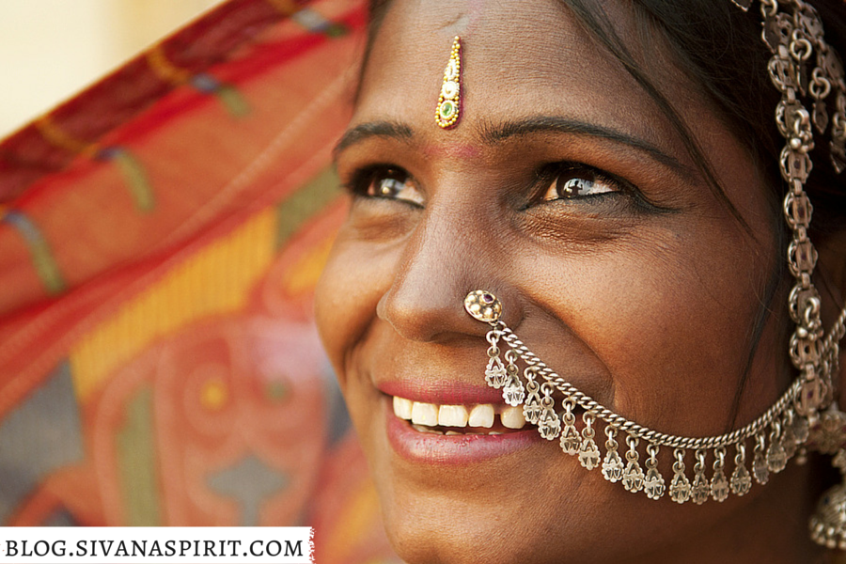
Bindis: Their History And Meaning

If you’ve ever seen a picture of the people of India, chances are you’ve seen a bindi. These small dots between the eyebrows are some of the most widely recognized cultural marks in the world, and carry with them a huge significance to the history of India.
Surprisingly, bindis are worn not only in India, but also Nepal, Bangladesh, Sri Lanka, Southest Asia, and Mauritius. Literally translated to “drop” or “small particle”, there are several variations of the decoration…from a paste to jewelry. Incredibly, this special mark has been used for almost 5,000 years, and is mentioned in India’s oldest text- the Rig Veda.

Spiritual Meaning
There are several meanings of the bindi, each one equally valid. According to tradition, the mark between the eyes represents the spiritual seat of consciousness: the third eye, or ajna. This is an extremely important part of the chakra system.
By concentrating and opening the spiritual center between the eyebrows, a practitioner can eventually learn how to exit their body at will. Though it is mainly worn by women, it was once worn by both women and men. From Vedic times (5,000 years ago), it was used to worship the intellect of both men and women to ensure that thoughts, speech, and action became pure. It’s thought that a strong intellect can help make spiritual decisions in life without fear.

Customs
In the present day, women take the bindi mark as a way to show they’re spoken for in marriage. It represents the life-long commitment to her husband and is often times removed once if she becomes a widow. Sometimes, a far more elaborate and symbolic bindi decoration is applied in order to ward off evil spirits or to bring good luck.

