Name: ___________________________________________ Class: _____________ Date: ____________
Art I Final Exam Review
Define the following terms:
Value ________________________________________________________________________________
_____________________________________________________________________________________
Show examples of value shading below.
Hatching | Cross-Hatching | Stippling/Pointellism | Blending | Squiggles

Shape _______________________________________________________________________________

_____________________________________________________________________________________
Draw 3 organic shapes and 2 geometric shapes below. Label which category each shape belongs to.

Color ________________________________________________________________________________

_____________________________________________________________________________________

List the primary colors
- _____________________________
- _____________________________
- _____________________________
List the secondary colors
- _____________________________
- _____________________________
- _____________________________

List the tertiary colors

- _____________________________
- _____________________________
- _____________________________
- _____________________________
- _____________________________
- _____________________________

Complementary colors are _____________________________________ each other on the color wheel.

Analogous colors are ______________________________________ each other on the color wheel.

List the complementary color:
Red | Blue | Yellow

Create a grouping of analogous colors
Primary color | Tertiary color | Secondary Color | Tertiary Color | Primary Color

Complete the color wheel below
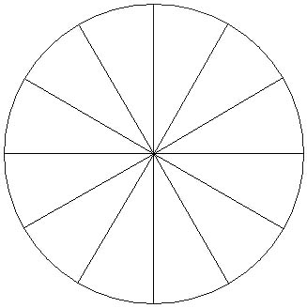

Form ________________________________________________________________________________
_____________________________________________________________________________________
Form can be ______________________, like a sphere, or ___________________ like a circle with value.

Draw the five basic implied forms below. Add value to one of them to show highlights and shadows.
Cone Sphere Cylinder Cube Pyramid

Line _________________________________________________________________________________
_____________________________________________________________________________________

Create five different types of line

Texture ______________________________________________________________________________
_____________________________________________________________________________________

Texture can be _________________________, like the chair you’re sitting on, or ______________________, like the photograph of a brick wall.

Space ________________________________________________________________________________
_____________________________________________________________________________________

Space can be _____________________ (occupied) or ______________________ (unoccupied).

Label the positive and negative space below.

Space can also be shown in landscapes. What three parts of an image are included with atmospheric perspective?
____________________________, _________________________________, ______________________

Label these areas in the image below
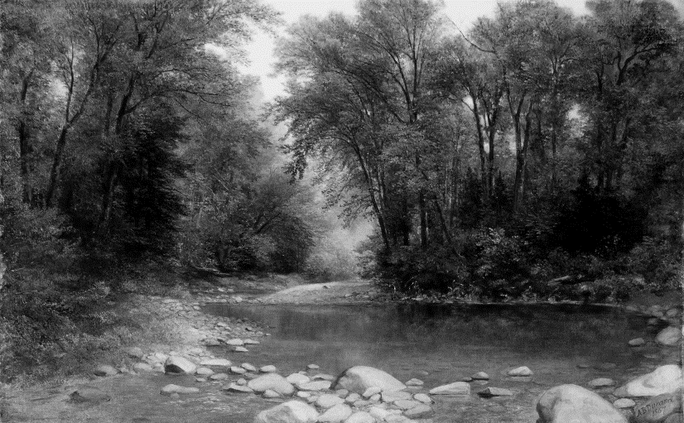

Match the correct term with the definition.
The area between the foreground & background
Colors that are across from each other on the color wheel

Colors made by mixing equal amounts of primary colors

Colors made with equal amounts of light
The three basic & most pure, from which all other colors can be made

Colors made by mixing a primary color with an analogous secondary color

Natural, freeform, irregular, asymmetrical, & is called by what it looks like or is associated with
Made by geometry, regular, symmetrical, & has a name

3D, deals with distance / spatial relationships & perspective
The area the is closest to the viewer & is lowest on the picture plane
The area that is farthest from the viewer & is highest on the picture plane
It gives the illusion of being 3D on a 2D surface
Is really there in the 3D world & can be felt
Natural, freeform, irregular, asymmetrical, & is called by what it looks like or is associated with
Made by geometry, regular, symmetrical, & has a name

ORGANIC SHAPE | FOREGROUND | PRIMARY COLORS | MIDDLE-GROUND | TERTIARY COLORS
COMPLIMENARY COLORS | GEOMETRIC SHAPE | IMPLIED FORM | PHYSICAL SPACE | POSITIVE SPACE
BACKGROUND | NEUTRAL COLORS | ACTUAL FORM | SECONDARY COLORS | NEGATIVE SPACE

