Art I – Quarter II Test
Each point is worth 2%.
Name: ______________________________________________ Date: ______________________ Class Pd. _________

Match the vocabulary work with the correct definition, choose from the multiple-choice bank below. (2pts each)
- Space
  - An element of art that refers to a 3D contained space; can be actual or implied & can also be geometric or organic.
  - An element of art that refers to a point moving in space, it has width, direction, & length.
  - An element of art referring to area in, around, or between objects
  - An element of art that refers to the relative lightness or darkness of an object
- Positive Space
  - The 3D area of space; has height, width, & depth
  - The area which is occupied by objects
  - The area / objects between the foreground & background on the picture plane
  - The empty area which is void of objects
- Negative Space
  - The area which is occupied by objects
  - The 3D area of space; has height, width, & depth
  - A value shading technique that uses repetitive lines going in the same direction
  - The empty area which is void of objects
- Physical Space
  - The 3D area of space; has height, width, & depth
  - The area which is occupied by objects
  - The empty area which is void of objects
  - The 2D illusion of space
- Middle Ground
  - The area /objects farthest from the viewer on the picture plane & is highest on the image above the horizon line
  - The area / objects closest to the viewer on the picture plane & is lowest on the image below the horizon line
  - The empty area which is void of objects
  - The area / objects between the foreground & background on the picture plane
- Illusion of Depth
  - An element of art referring to area in, around, or between objects
  - A value shading technique that uses repetitive lines going in the same direction
  - An element of art that refers to the surface quality of an object, can be actual or implied
  - Drawing 3D physical space depicted on a 2D surface, giving it the appearance of depth
- Value
  - An element of art referring to the relative lightness or darkness of an area / object
  - An element of art that refers to the surface quality of an object, can be actual or implied
  - The blending stump used to create a smooth shading technique
  - An element of art that refers to the area around, between, or within objects
- Fill in the blanks with either background or foreground. (4pts.)
The area /objects farthest from the viewer on the picture plane & is highest on the image above the horizon line
The area / objects closest to the viewer on the picture plane & is lowest on the image below the horizon line

- Name 2 kinds of light sources: (4pts)
______________________________________ _______________________________________

- In the boxes below, create a value scale. (4pts)
LIGHT |  |  |  | DARK

- Draw the correct value shading technique in the box below the named technique. (5pts)
HATCHING | CROSS HATCHING | STIPPLING / POINTILISM | BLEND | SCRIBBLE

- Show the form of the object below by adding value to make it appear 3D. Add highlights, mid-tones, & shadows. (5pts.)

- In the picture below, clearly draw lines to & label the positive & negative spaces. (4pts.)

- In the landscape below, clearly draw lines to & label the foreground, middle ground, & background. (6pts)
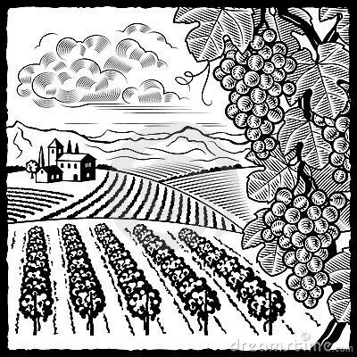

- In the landscape above there are several illusions of depth, choose one & explain where specifically you see it. (4pts.)
Illusions of Depth: overlapping, object location or size, change in detail, color, or value

__________________________________________________________________________________________________________________________________________________________________________________________________________________________________________________________________________________________________________________________________________________________________________________________________________________________________________________________________________________________________________________________________________________________________
_________________________________________________________________________________________________________________________________________________________________________________________________________________________________________________________________________________

