Name: __________________________________________ Date: _____________________ Class: __________________
Q3 Test Review
Fill in the correct element of art from the bank below. 2 pts each
COLOR | FORM | TEXTURE

The way something feels or looks like it feels

A 3D contained space

The light that is reflected into the eye

Circle the correct word that matches the definition. 2 pts each

Actual Texture / Implied Texture: The way something looks like it might feel if it could be touched
Actual Texture / Implied Texture: The way something feels to the sense of touch

Actual Form / Implied Form: The illusion of form on a 2D surface
Actual Form / Implied Form Forms that have height, width, & depth

Warm Color/Cool Color: Colors that are vivid and bold in nature, often push forward in a composition
Warm Color/Cool Color: Colors that are calm or soothing in nature, often recede in a composition

Complementary/Analogous: Colors that are opposite of each other on the color wheel
Complementary/Analogous: Colors that are beside each other on the color wheel

Color the 3 primary colors in the boxes below. 1 pt each

Color the 3 secondary colors in the boxes bellow. 1 pt each

Name the 4 neutral colors. 1 pt each
________________________________________ __________________________________________
________________________________________ __________________________________________

Draw 2 examples of textures & describe them. 4 pts

Make a letter using implied form from a bird’s eye view. 5 pts

Make a letter using implied form from a worm’s eye view. 5 pts

Draw 1 shape and turn it into an implied form using value. 5 pts

Use primary & secondary colors to create a color wheel below. Use these colors to mix for your tertiary colors. 12 pts
Draw an example of a simple mandala over your color wheel. 6 pts

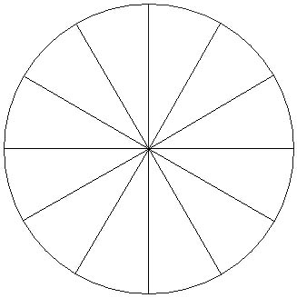

What is typography? 1 pts __________________________________________________________________________________________________
__________________________________________________________________________________________________
Give 3 examples of places typography is found/used. 3pts
1. _______________________________
2. _______________________________
3. _______________________________

Draw an object using typography & color it in. 7 pts.

