Drawing Portfolio: Sustained Investigation

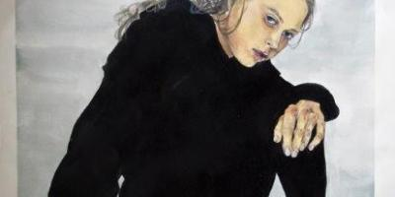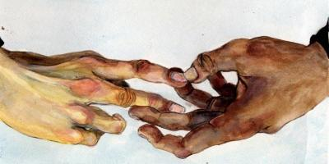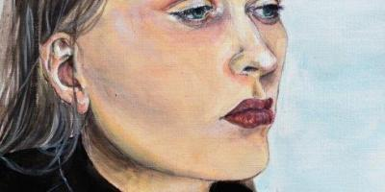

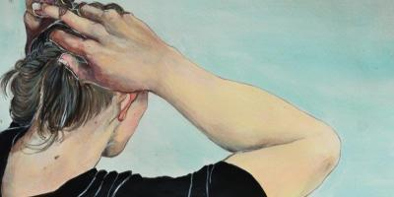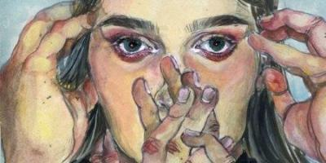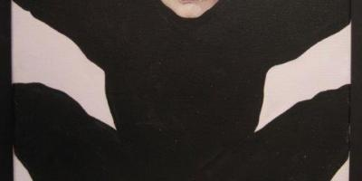

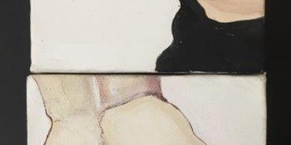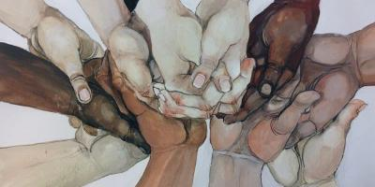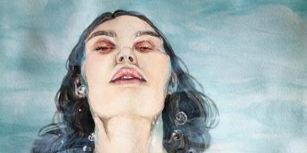

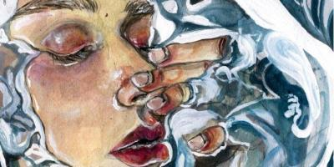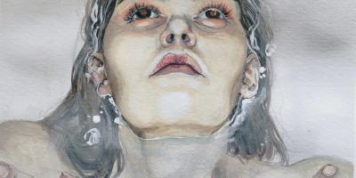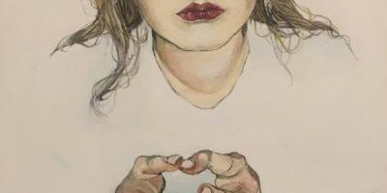
Sustained Investigation (Concentration) Statement
- The title of my concentration is "Equilibrium." It is a series of self-portraits depicting the complicated road that must be overcome to acquire peace, a fight against yourself, to let go and to forgive. This can be related to the idea of death. Death being the struggle of letting go or accepting the truth, and life representing the final step of overcoming and recognizing that some things can not be changed, and that it is okay. Two opposing forces reaching a point of balance, an equilibrium.
- The first piece was inspired by the traits in Egon Schiele’s “Seated Woman With Bent Knee.” The finger joints being exaggerated and the unsettling look in the face was because of the anger and confusion in me. The black silhouette was it’s heaviness left behind. Piece 2 is the hand of the loved one who is no longer with me. The iconic “Adam and God” painting by Michelangelo is intentionally alluded showing the loss of someone dear to me rather than the “start of life” as intended by Michelangelo. The next piece, 3, is continuing from the loss of this person and how misplaced I felt without them. One of the things I noticed when they had left, was that my physical health started to swing. I lost a lot of hair because I became more stressed, it felt like I was tied down. This is the representation of the braids. Paintings 5 and 6 are displaying my mental health and its uneasiness, my hands attempting to silence my mind. Paintings 7-8 is the final action of speaking up and asking for help, the hands surrounding mine are my friends and family. Paintings 9-10 can be connected to the action of baptism, death and rebirth. This is where I finally let go of it all. Piece 11 being the last stop and resting point, and the closing piece 12, showcasing the calm state and finally acquiring balance.

2D Portfolio: Sustained Investigation
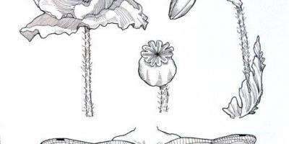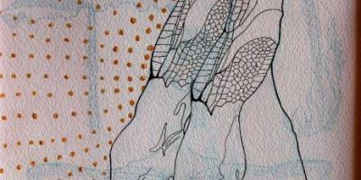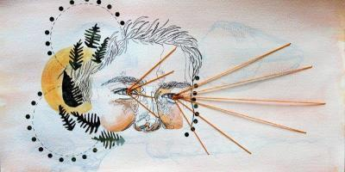

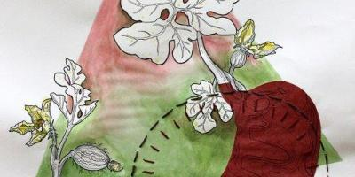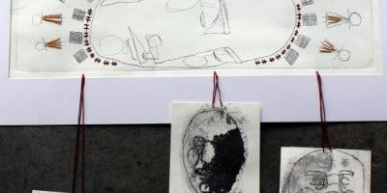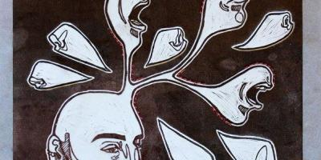

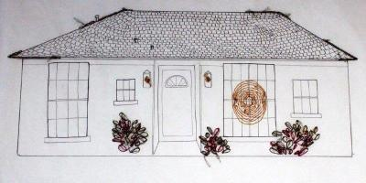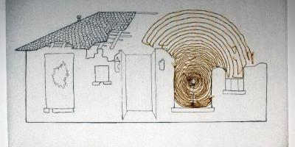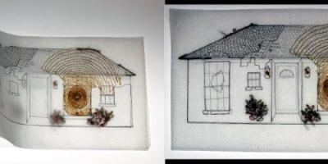

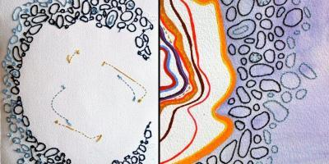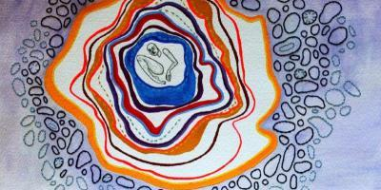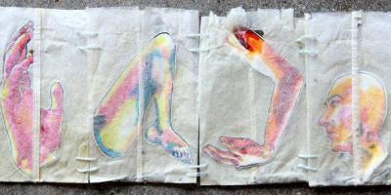

- My concentration revolves around the myths I believed in as a child, which helps me understand what beliefs and ideas have shaped me into the person I am now.
- Throughout this series, I explore the ways certain myths have marked my character, beginning with childish ideas to the manipulation of my beliefs about my reality. By beginning with fairies, a light-hearted tone is established, giving me room to cherish the sweet memories of dancing in gardens (in the wings on fairy feet in image 2). Experimenting with perception in pieces 2 and 3 by layering over illustrations brings depth and complexity, moving beyond traditional boundaries. Moving to the myths surrounding my history, I merged a wiry contour style in piece 5 with an intricate Cherokee and Apache myth about the creation of the sun- which I believed had to do with why my skin became lobster red in the summertime. Warm colored embroidery adds to the tribal pattern, and the heavily etched plates suspended below represent being burned while admiring the sun’s face. Even these sweet memories transition to the darker beliefs that burdened my childhood. Insecurity about my bent nose clouded my mind (in piece 6) and the broken nature of my home life left me wading in fear (in pieces 7-9). Transparent paper signifies the feelings of being worn thin. The loneliness associated with these feelings translate through the canyon-colored boundaries I built around my broken frame (in piece 11).

TIPS FOR WRITING:
Part 1: General, overall idea about your works of art. Where did you get your inspiration for your idea? How did it develop through your pieces, and why did you title your series of artworks with this title?
Part 2: Specifics!!! The first pieces, how they transformed for you into your more elaborate pieces. Were there specific artworks or places where you found your inspiration? Note specific artwork numbers for each explanation you are giving. Tell us here how your series of art developed into what your final pieces became. Don’t reference your teacher, reference artworks or moments that inspired you. Find specific details in the pieces that made the next artwork stand out.

