1. Salvador Dali, “Sleep” 1937
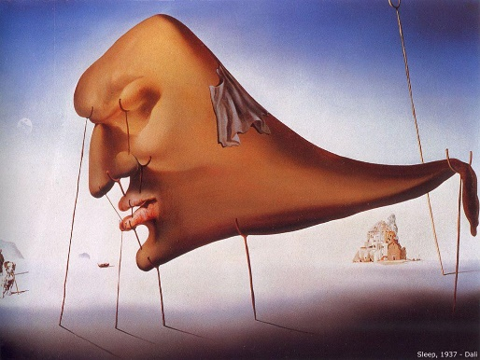

2. Henri Magritte, “The Son of Man” 1946
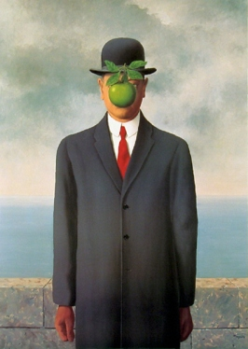

3. Jacek Yerka, “Dream” 2011
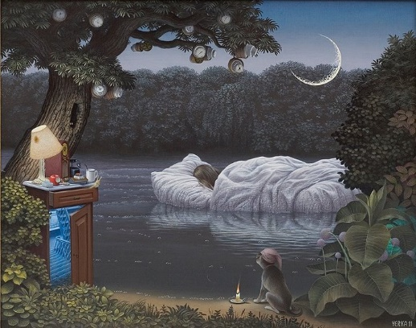

4. M.C. Escher, “Relativity” 1953
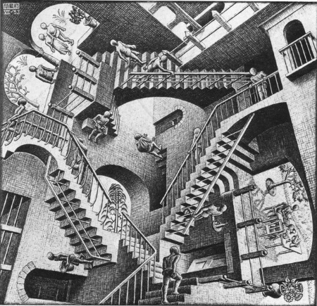

5. Max Ernst, “L’Ange du Foyer” 1937
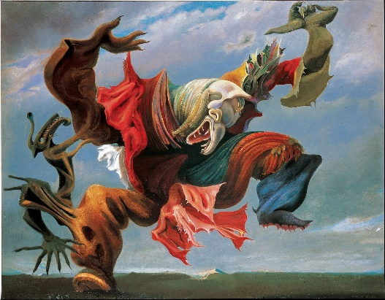

6. Remedios Varo Uranga, “Creation of the Birds” 1957
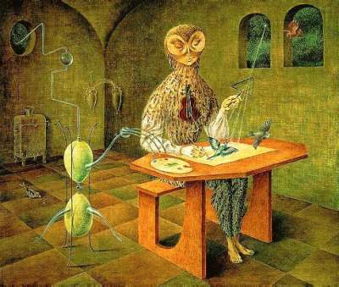

7. Josephine Wall, “Winter Dreaming”
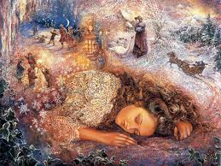

8. Henry Fuseli, “The Nightmare” 1781
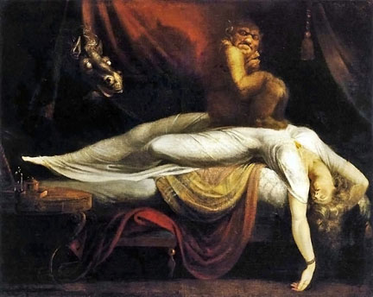

9. Luis Beltran, “El Gran Viaje” (“The Great Journey”) 2010
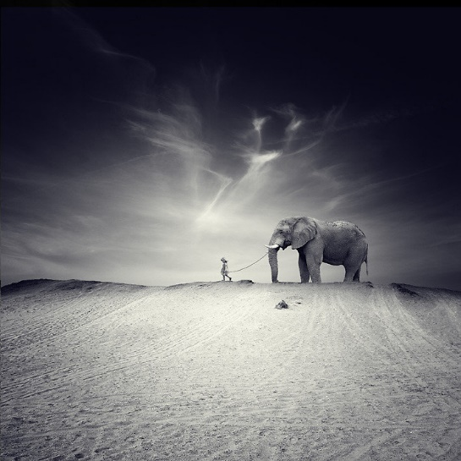

10. Katerina Plotnikova, “Girl and Bear”
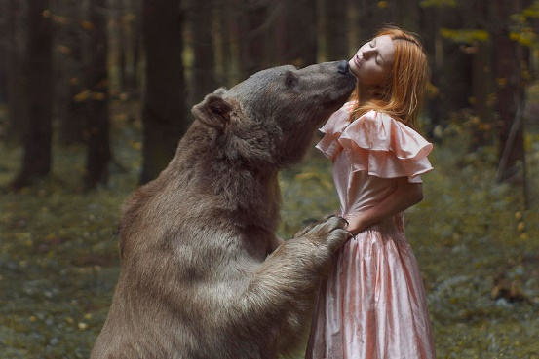

11. Jaume Plensa, “The Dream Sculpture”
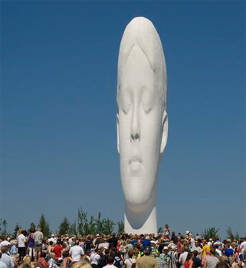

12. Francisco Goya, “The Sleep of Reason Produces Monsters” 1799
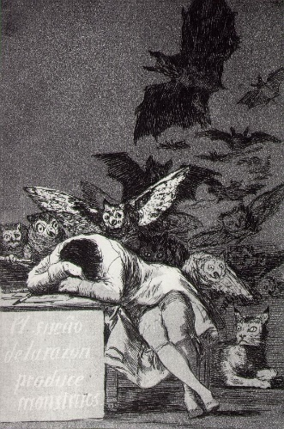

13. Antonio de Pereda, “The Knight’s Dream” 1655
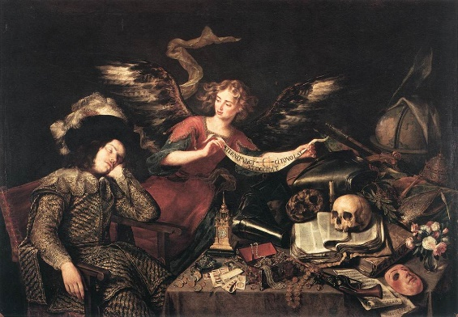

14. Andrew Wyeth, “Master Bedroom”
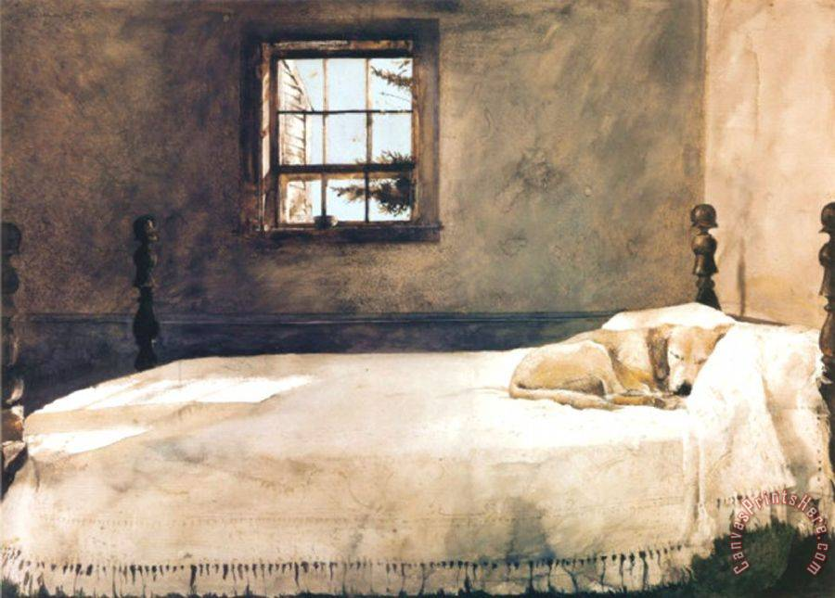

15. Jusepe de Ribera, “Jacob’s Dream” 1639
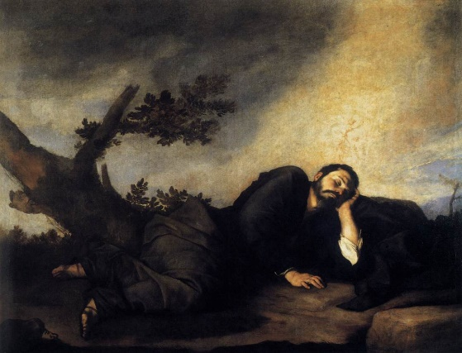

16. Alexander Jansson, “Whimsical Illustration”
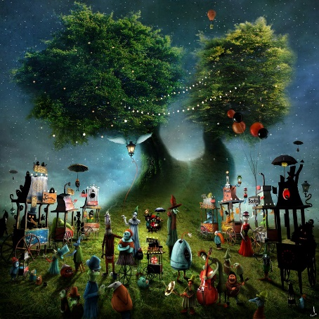

17. Vittore Carpaccio, “The Dream of Saint Orsola” 1495
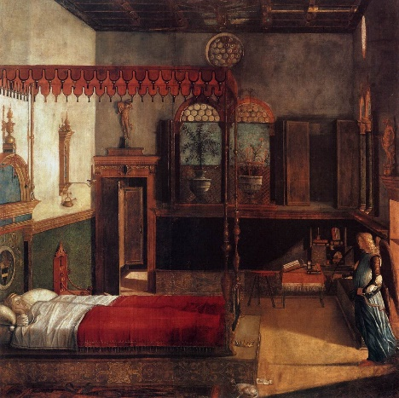

18. Caravaggio, “Sleeping Cupid” 1608
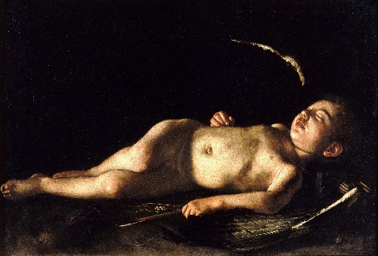

19. Pablo Picasso, “The Dream” 1932
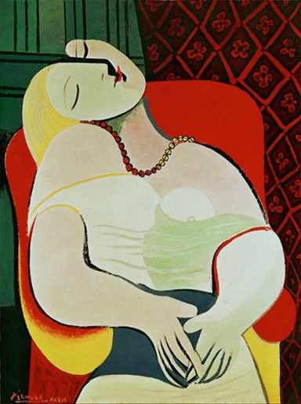

20. Henri Magritte, “El Cheque en Blanco” (“The Blank Check”) 1965
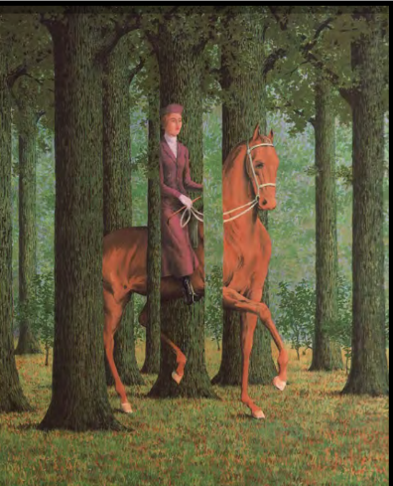

21. Hans Zatzka, “The Sleeping Beauty”
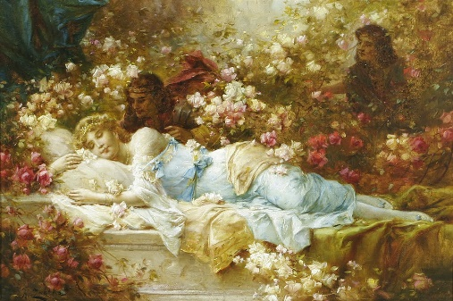

22. Ben Heine, “Pencil vs. Camera”
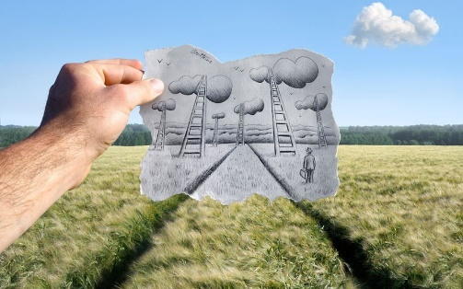

23. Joan Miro, “Carnival of Harlequin” 1924-1925
