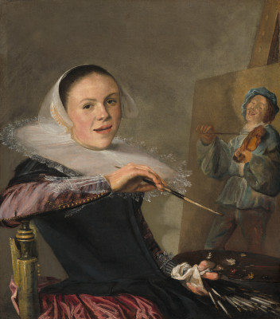
1

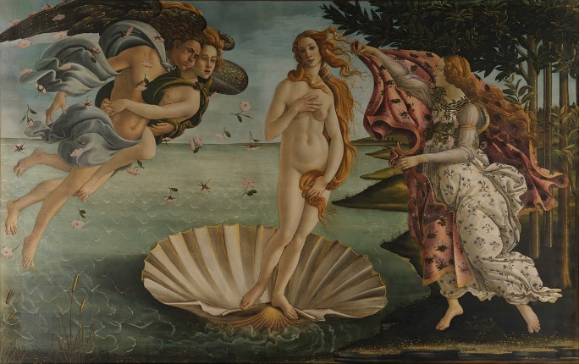
2

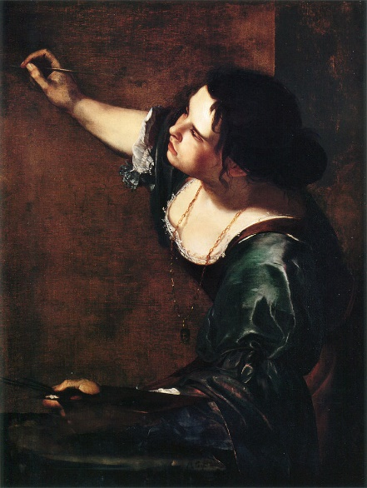
3

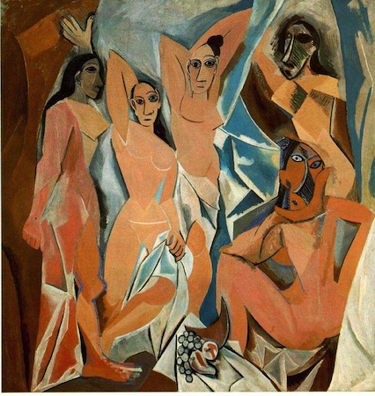
4
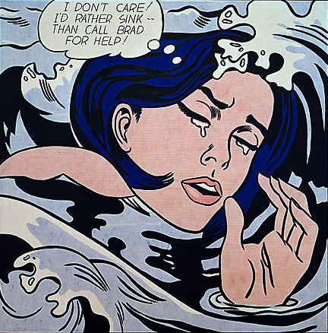
5

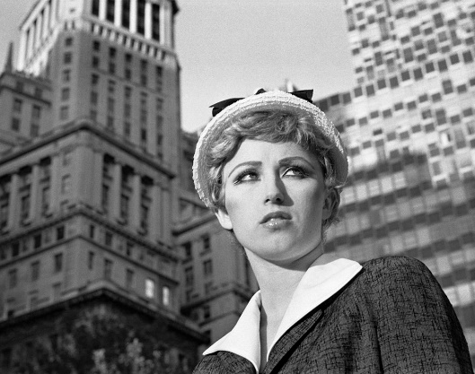
6
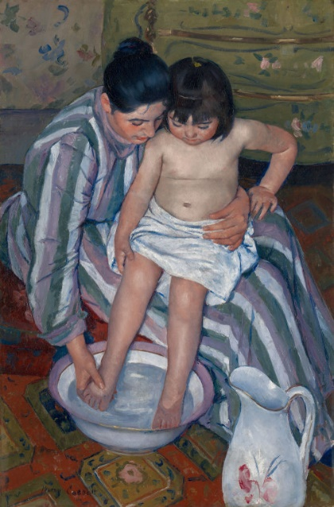
7

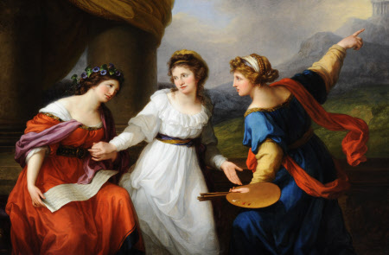
8

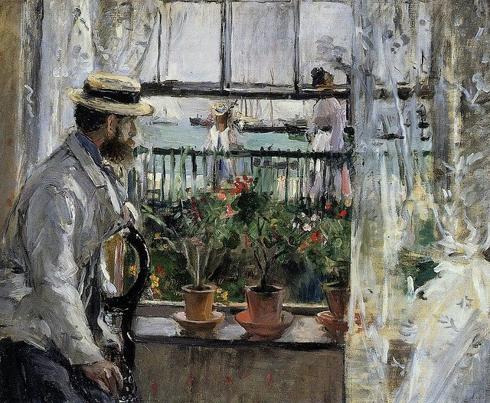
9

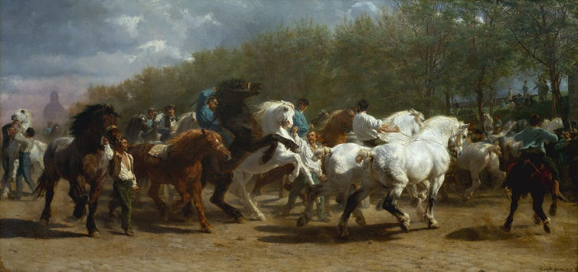
10

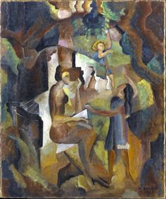
11

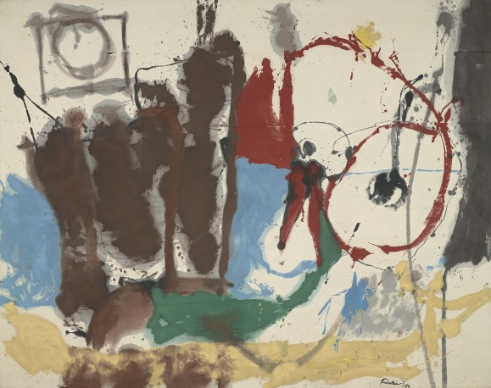
12

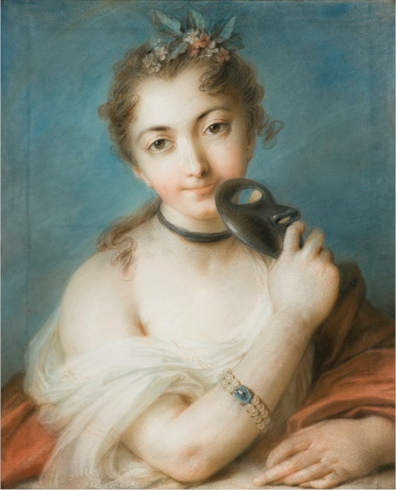
13

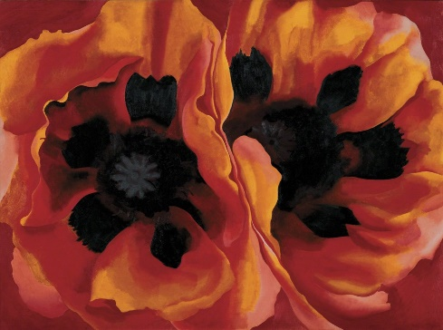
14

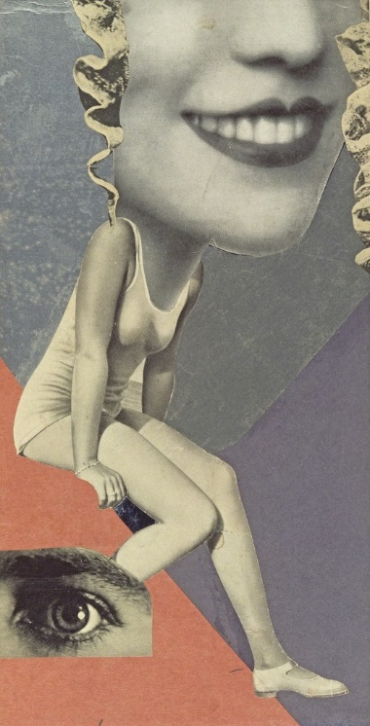
15

1. Judith Leyster “Self-Portrait” 1630
2. Botticellii “The Birth of Venus” 1484-1486
3. Artemisia Gentileschi “Self-Portrait” 1639
4. Pablo Picasso “Les Demoiselles d’Avignon” 1907
5. Roy Lichtenstein “Drowning Girl” 1963
6. Cindy Sherman “Untitled Film Still #21” 1978
7. Mary Cassatt “The Child’s Bath” 1893
8. Angelica Kauffman “Self-Portrait, the Artist Hesitating Between the Arts of Music and Painting.” 1794
9. Berthe Morisot “Eugene Manet on Isle of Wight” 1875
10. Rosa Bonheur “The Horse Fair” 1852-1855
11. Marguerite Thompson Zorach “Memories of My California Childhood” 1921
12. Helen Frankenthaler “Mother Goose Melody” 1959
13. Rosalba Carriera “Female Portrait with Mask” 1720-1730
14. Georgia O’Keeffe “Oriental Poppies” 1927
15. Hannah Hoch “Made for a Party” 1936

