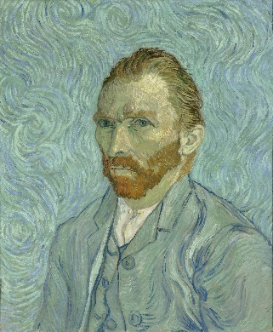
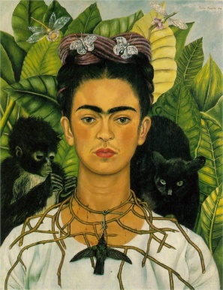
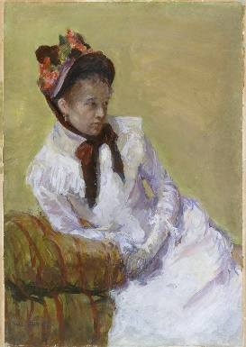
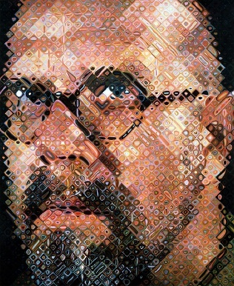

1 2 3 4

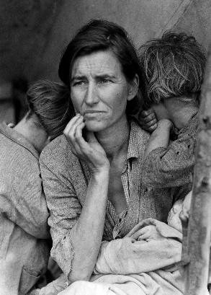
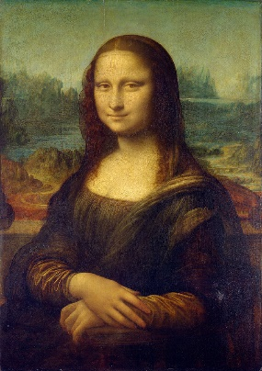
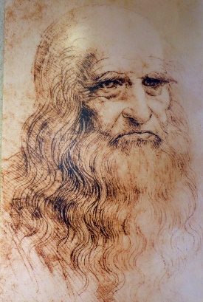
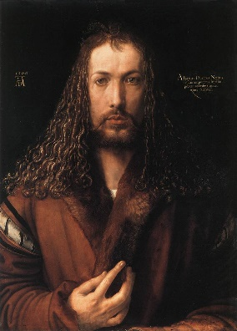

5 6 7 8

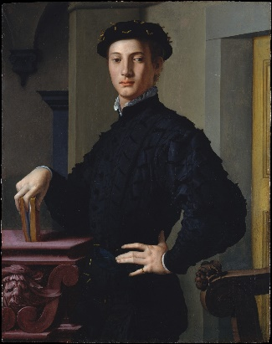
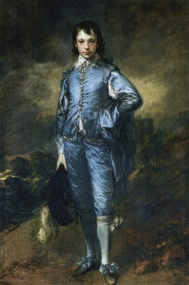
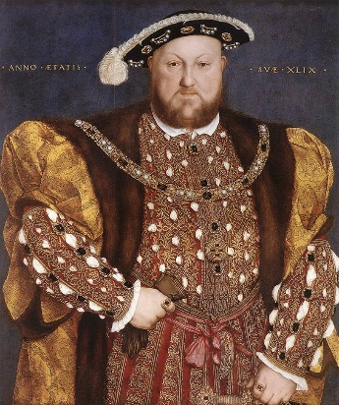
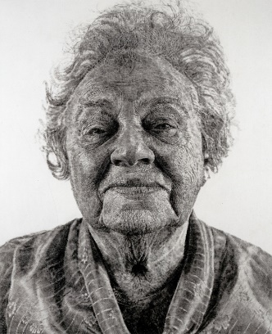

9 10 11 12

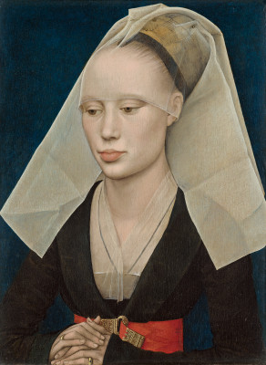
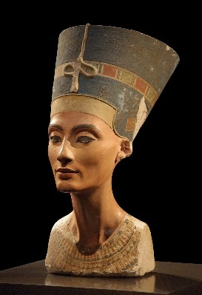
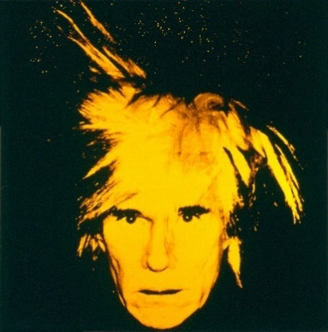
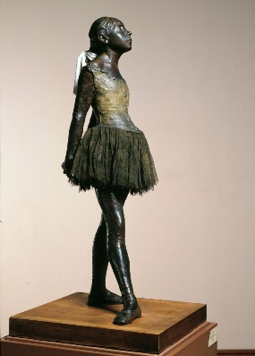

13 14 15 16
1. Chuck Close, “Self-Portrait”, 1997, oil on canvas. Museum of Modern Art, NYC

2. Mary Cassatt, “Self-Portrait”. 1878, gouache on paper. Metropolitan Museum of Art, NYC

3. Frida Kahlo, “Self-Portrait”. 1940

4. Vincent VanGogh, “Self-Portrait”. 1889, oil on canvas. Musee d’Orsay, Paris, France

5. Dorothea Lange, “Migrant Mother”, 1936.

6. Leonardo da Vinci, “Mona Lisa”, 1503 - 1504. The Louvre Museum, Paris, France

7. Leonardo da Vinci, “Self-Portrait”, 1512 – 1515.

8. Albrecht Dürer, “Self-Portrait”. 1500, oil on wood panel. Alte Pinakothek, Munich

9. Bronzino (Agnolo di Cosimo di Mariano), “Portrait of a Young Man”, 1530. Oil on wood.

10. Hans Holbein the Younger, “Portrait of Henry VIII”, 1540.

11. Chuck Close, “Fanny/Fingerpainting”. 1985, oil on canvas. National Gallery of Art, Washington DC

12. Thomas Gainsborough, “The Blue Boy”, 1770. The Huntington Library Art Collections & Botanical Gardens, San Marino, California

13. Rogier van der Weyden, “Portrait of a Lady”, 1460. Oil on panel, National Gallery of Art, Washington DC

14. Edgar Degas, “Little Dancer of Fourteen Years”, 1879 – 1880. Wax & bronze sculpture

15. Andy Warhol, “Self-Portrait”, 1986. Acrylic paint and screenprint on canvas.

16. Queen Nefertiti, 1360 BC. Limestone. Ȧgyptisches Museum, Staaliche Museum, Berlin, Germany

